**FACIAL JUSTICE: IDENTIFING CRIMINALS FOR A SAFER SOCIETY**

A report submitted in partial fulfilment of the requirements for the Degree of

**Bachelor of Technology**

in

**Computer Science and Engineering(Cyber Security)**

**By**

A. Veena 2011CS040005

CH. Harsha Vardhan 2011CS040014

K. Sai Jayanth 2011CS040049

**Under the esteemed guidance of**

Mr. P. Ravinder

(Assistant Professor)



**Department of Computer Science & Engineering CyberSecurity**

**School of Engineering**

**MALLA REDDY UNIVERSITY**

Maisammaguda, Dulapally, Hyderabad, Telangana 500100

**2024**



**Department of Computer Science & Engineering (Cyber Security)**

**CERTIFICATE**

This is to certify that the project report entitled “**FACIAL JUSTICE: IDENTIFING CRIMINALS FOR A SAFER SOCIETY”**, submitted by **A.Veena (2011CS040005), CH. Harsha Vardhan (2011CS040014), K. Sai Jayanth (2011CS040049),** towards the partial fulfilment for the award of Bachelor’s Degree in (Cyber Security) from the Department of Computer Science and Engineering), Mall Reddy University, Hyderabad, is a record of bonafide work done by him/ her. The results embodied in the work are not submitted to any other University or Institute for award of any degree or diploma.

|  |  |  |
| --- | --- | --- |
| **Internal Guide:**  Mr. P. Ravinder  (Assistant Professor) |  | **Head of the Department**  Dr. G. Anand kumar |
|  | External Examiner |  |
|  |  |  |

**DECLARATION**

We hereby declare that the project report entitled “**FACIAL JUSTICE: IDENTIFING CRIMINALS FOR A SAFER SOCIETY**” has been carried out by us and this work has been submitted to the Department of Computer Science and Engineering (Cyber Security), Malla Reddy University, Hyderabad in partial fulfilment of the requirements for the award of degree of Bachelor of Technology. We further declare that this project work has not been submitted in full or part for the award of any other degree in any other educational institutions.

Place:

Date:

|  |  |  |  |
| --- | --- | --- | --- |
| 1. Veena | | 2011CS040005 |  |
| Ch. Harshavardhan | | 2011CS040014 |  |
| K. Sai Jayanth | | 2011CS040049 |  |
|  |

**ACKNOWLEDGEMENT**

We extend our sincere gratitude to all those who have contributed to the completion of this project report. Firstly, We would like to extend our gratitude to Dr. V. S. K Reddy, Vice-Chancellor, for his visionary leadership and unwavering commitment to academic excellence.

We would also like to express my deepest appreciation to our project guide Mr. P. Ravinder, Assistant Professor, whose invaluable guidance, insightful feedback, and unwavering support have been instrumental throughout the course of this project for successful outcomes.

We are also grateful to Dr. G. Anand kumar, Head of the Department of Cybersecurity, for providing us with the necessary resources and facilities to carry out this project.

We would like to thank Dr. Kasa Ravindra, Dean, School of Engineering, for his encouragement and support throughout my academic pursuit.

My heartfelt thanks also go to Dr. Harikrishna Kamatham, Associate Dean School of Engineering for his guidance and encouragement.

We are deeply indebted to all of them for their support, encouragement, and guidance, without which this project would not have been possible.

A.Veena (2011CS040005)

CH. Harsha Vardhan (2011CS040014)

K. Sai Jayanth (2011CS040049)

**Abstract**

Developing software for criminal identification, particularly through facial recognition, is a critical endeavor in law enforcement. With technological advancements, such software can significantly enhance the efficiency and accuracy of identifying individuals involved in criminal activities. However, it's important to consider the ethical and privacy implications associated with such technology.

Facial recognition software utilizes algorithms to analyze facial features and match them against a database of known faces. Despite its potential benefits, there are challenges, particularly when dealing with poor-quality images or surveillance footage. The accuracy of facial recognition algorithms can be affected by factors such as lighting, angle, resolution, and occlusions.

To address these challenges, researchers are continuously working on improving the performance of facial recognition systems. One approach involves using advanced image processing techniques to enhance the quality of images, such as noise reduction, edge detection, and image enhancement. Additionally, machine learning algorithms can be trained on a large dataset of high-quality facial images to improve their ability to recognize faces accurately.

In addition to technical challenges, there are also ethical considerations surrounding the use of facial recognition technology. Privacy advocates raise concerns about the potential for misuse of facial recognition data, including mass surveillance and the infringement of individuals' rights to privacy. There are also concerns about the potential for bias in facial recognition algorithms, particularly when it comes to accurately identifying individuals from different demographic groups.

To address these concerns, it's essential to implement robust privacy safeguards and ensure transparency and accountability in the use of facial recognition technology. This includes obtaining informed consent from individuals whose facial data is being collected, implementing strict data protection measures to safeguard against unauthorized access or misuse, and regularly auditing facial recognition systems to identify and address any biases or inaccuracies.

Despite these challenges, facial recognition technology holds immense potential for enhancing public safety and aiding law enforcement agencies in identifying and apprehending criminals. By continuing to invest in research and development and ensuring responsible deployment and use, we can harness the benefits of facial recognition technology while mitigating its risks and ethical concerns.

**CONTENTS**

**List of Figures:**

Figure 4.1 Architecture

Figure 4.2 Data Flow Diagram

Figure 4.3 Class Diagram

Figure 4.4 Use Case Diagram

Figure 4.5 Sequence Diagram

Figure 4.6 Administrator

Figure 4.7 Operator

Figure 4.8 Collaboration Administrator Diagram

Figure 4.9 Collaboration Operator Diagram

Figure 5.1 Spiral Model

Figure 5.2 N-Tier Architecture

Figure 6.1 Subsystem

Figure 7.1 Java Swing Class Hierarchy

Figure 7.2 JVM

Figure 7.3 Compilation of Code

Figure 8.1 Execution Flow

**List of Screenshots:**

Figure 9.1 Home Page Layout

Figure 9.2 Sign-up Page

Figure 9.3 User Sing- Up Page

Figure 9.4 Sing-Up Success

Figure 9.5 Sing-In Page

Figure 9.6 Eyewitness Page

Figure 9.7 Image Selection Page

Figure 9.8 Image Found Page

Figure 9.9 Operator Page

Figure 9.10 To View Details Page

Figure 9.11 Criminal Details Page

Figure 9.12 New Details Page

Figure 9.13 New Image Upload Page

Figure 9.14 Deletion and Updation Page

Figure 9.15 Admin Login Page

Figure 9.16 Administrator Page

Figure 9.17 Login Id Details Page

Figure 9.18 To Delete Accounts Page

**Contents Page No.**

**Chapter 1**

**Introduction 1-3**

* 1. Problem Definition & Description 1
  2. Objectives of the Project 2
  3. Scope of the Project 2-3

**Chapter 2**

Literature Survey 4-6

**Chapter 3**

**System Analysis**

3.1 Existing System

3.2 Proposed System

3.2.1 Advantages of Proposed System

3.3 Software & Hardware Requirements

3.3.1 Hardware Requirements

3.3.2 Software Requirements

3.4 Feasibility Study

3.4.1 Technical Feasibility

3.4.2 Economic Feasibility

3.4.3 Operational Feasibility

**Chapter 4**

4.1 Modules Design

4.1.1 User Interface Module

4.1.2 Admin Module

4.1.3 Client Module

4.1.4 Database Operation Module

4.1.5 Splitting and Merging Module

4.1.6 Identify Module

4.1.7 Testing Module

4.1.8 Results Module

4.2 Project Architecture

4.2.1 Complete Architecture

4.2.2 Data Flow Diagram

4.2.3 Class Diagram

4.2.4 Use Case Diagram

4.2.5 Sequence Diagram

4.2.6 Activity Diagram

4.2.7 Collaboration Diagram

**Chapter 5**

**Methodologies**

5.1 SDLC Methodologies

5.2 Advantages

5.3 Application Development

5.3.1 N-Tier Application

5.3.2 Definition

5.3.3 Steps for Method

5.3.4 Algorithm

**Chapter 6**

**System Design**

6.1 Breaking the System into Subsystems

6.2 Identifying Concurrency

6.3 Allocating Subsystems to Processor

6.4 Management of Data Stores

6.5 Choosing Software Control

**Chapter 7**

7.1 Features of the Language Used

7.1.1 About Java

7.1.2 Swings

7.1.3 Java Swing Class Hierarchy

**Chapter 8**

**Implementation & Testing**

8.1 Code

8.2 Execution Flow

8.3 Testing

8.3.1 Test Case 1

8.3.2 Test Case 2

8.3.3 Test Case 3

8.3.4 Test Case 4

**Chapter 9**

9.1 Resulting Screen

**Chapter 10**

**Conclusion and Future Scope**

10.1 Conclusion

10.2 Future Scope

**REFERENCES**

**CHAPTER 1**

**Introduction**

* 1. **Problem Definition & Description:**

The project aims to streamline the process of identifying criminals using eyewitness accounts, facilitated by a software system comprising four main modules: Adding, Deleting, Updating, and Criminal Identification. Additionally, the project involves three distinct user roles: Administrator, Operator, and Eyewitness, each with specific responsibilities and access levels within the system.

Firstly, the Administrator role is tasked with managing user authentication and access control. This includes assigning User IDs and passwords, as well as creating, deleting, and updating user accounts as needed. By overseeing user credentials, the Administrator ensures secure access to the system and maintains the integrity of user data.

Secondly, the Operator role, typically belonging to the investigating department, plays a crucial role in inputting and managing criminal data within the system. Operators are responsible for adding, deleting, and updating criminal records, thereby maintaining an up-to-date database of suspects. Additionally, operators collaborate with eyewitnesses to construct composite faces of criminals using cropped image parts stored in a separate database. This collaborative effort involves selecting relevant image segments provided by eyewitnesses and assembling them to form a complete facial composite of the suspect.

Thirdly, the Eyewitness role involves individuals who provide crucial visual information regarding suspects. Eyewitnesses contribute to the identification process by selecting cropped image parts from the database, which they believe represent features of the suspect's face. These selected image segments are then used by operators to construct composite facial images for identification purposes. Furthermore, eyewitnesses have the opportunity to review and validate the constructed facial composites to ensure accuracy in suspect identification.

The system operates through a collaborative workflow between operators and eyewitnesses. Operators collect and manage criminal data, while eyewitnesses provide visual input to aid in suspect identification. By integrating these roles and functionalities, the system streamlines the identification process and enhances collaboration between law enforcement personnel and eyewitnesses.

Moreover, the system facilitates the construction of composite facial images from cropped image parts, enabling investigators to visualize potential suspects based on eyewitness descriptions. This feature enhances the accuracy and efficiency of criminal identification efforts, ultimately aiding in the apprehension of suspects and the prevention of criminal activities.

**1.2 Objectives of the Project:**

The project focuses on developing a system for person identification using previously captured images. Rather than focusing on identifying criminals specifically, this system aims to identify individuals based on their stored images. This can have various applications, including access control, attendance tracking, or verification processes in various domains such as security, banking, or healthcare.

The core functionality of the system involves comparing a new image of a person with a database of previously taken images of different individuals. This database serves as a reference repository containing images along with corresponding identification information. When a new image is provided for identification, the system utilizes image processing and pattern recognition algorithms to analyze and extract unique features or characteristics from the image.

These extracted features are then compared against the features extracted from the images stored in the database. The comparison process involves assessing the similarity between the features of the new image and those of the stored images using similarity metrics or classification techniques. If a sufficiently close match is found, the system identifies the person associated with the closest matching image in the database.

To ensure accurate and reliable identification, the system may employ advanced techniques such as facial recognition, biometric data analysis, or machine learning algorithms. These techniques enable the system to handle variations in lighting conditions, facial expressions, or pose differences that may occur between the new image and the stored images.

Additionally, the system may incorporate mechanisms for user authentication and access control to regulate access to sensitive information stored in the database. This helps prevent unauthorized access and ensures that only authorized personnel can perform identification tasks using the system.

Furthermore, the project emphasizes the importance of data privacy and security, implementing measures to safeguard the confidentiality and integrity of the stored images and associated identification information. This includes encryption, access controls, and compliance with relevant data protection regulations to mitigate risks associated with data breaches or misuse.

**1.3 Scope of the Project:**

* **Image Storage:** Develop a system to store images of individuals in a database. Implement a structured approach to organize and manage the stored images efficiently.
* **Database Management:** Design a database schema to accommodate image storage along with associated details of individuals. Implement database management functionalities for adding, updating, and deleting image records.
* **Image Retrieval:** Develop mechanisms to retrieve images from the database based on specified criteria such as individual's name, ID, or other identifying information.
* **Comparison Algorithm:** Design and implement an image comparison algorithm to compare a new image with the images stored in the database.
* **Identification Process:** Define the process flow for identifying individuals based on the comparison results. Implement decision-making logic to determine the closest match between the new image and the images stored in the database.
* **User Interface:** Develop a user-friendly interface for interacting with the system. Include features for uploading new images, specifying search criteria, and viewing identification results.
* **Error Handling:** Implement error handling mechanisms to deal with exceptions and inconsistencies in image data or database operations. Provide informative error messages and prompts for users to resolve issues effectively.
* **Security Measures:** Incorporate security measures to protect the confidentiality and integrity of stored images and database records. Implement user authentication and access control mechanisms to regulate access to sensitive information.
* **Testing and Validation:** Conduct thorough testing of the system to ensure accuracy and reliability in image comparison and identification processes. Validate the system's performance against predefined criteria and use cases.
* **Documentation and Training:** Prepare comprehensive documentation covering system architecture, functionality, and usage instructions. Provide training sessions or materials for users to familiarize themselves with the system operation and best practices.
* **Scalability and Performance:** Design the system with scalability in mind to accommodate future expansion of image storage and user base. Optimize system performance for efficient image retrieval and comparison operations, even with large datasets.
* **Compliance and Regulations:** Ensure compliance with relevant regulations and standards governing data privacy and protection.

**CHAPTER 2**

**Literature Survey**

**SanikaRatnaparkhi, AamaniTandasi, Shipra Saraswat:** The process of identifying and locating criminals traditionally involves laborious and time-consuming methods. However, leveraging cutting-edge face recognition technology presents a swift and straightforward alternative. By harnessing advanced algorithms and machine learning techniques, face recognition technology offers rapid and accurate identification of individuals.

With face recognition technology, law enforcement agencies can expedite the process of spotting and apprehending criminals. Through the analysis of facial features and patterns, the system swiftly matches faces against existing databases, enabling authorities to identify suspects in a matter of seconds rather than hours or days.

Moreover, face recognition technology simplifies the identification process for law enforcement personnel, eliminating the need for manual comparison and analysis of photographs or eyewitness accounts. Instead, the system automates the identification process, allowing officers to focus their efforts on investigative tasks rather than administrative duties.

Overall, the adoption of cutting-edge face recognition technology represents a significant advancement in law enforcement capabilities. By providing a quick and efficient means of identifying and locating criminals, this technology enhances public safety and contributes to the swift resolution of criminal investigations.

**P Apoorva, H.C.Impana, S.L.Siri :** The paper introduces a real-time face recognition system designed for automated surveillance cameras. The proposed system comprises four distinct steps to facilitate efficient and accurate face recognition in dynamic environments.

Firstly, the system undergoes a training phase where real-time images are utilized to train the recognition model. This step is crucial for ensuring the system's ability to accurately identify faces under varying conditions.

Following the training phase, the system employs a Haar-classifier for face detection. This classifier enables the system to detect and localize human faces within the surveillance camera's field of view, even amidst complex backgrounds or challenging lighting conditions.

Once faces are detected, the system proceeds to compare the trained real-time images with the images captured by the surveillance camera. This comparison process involves analyzing facial features and patterns to determine potential matches.

Finally, the system generates results based on the comparison, providing feedback on the identification status of each detected face. This step enables security personnel or relevant authorities to take appropriate action based on the system's findings, such as alerting staff or initiating further investigation.

The face detection system uses a deep neural network using a machine learning algorithm which can be introduced as a hassle-free criminal identification system. The hardware requirement includes a camera module mainly CCTV. The main focus of the project is on mapping special feature that includes beard, hair, lips, etc. The recognition of face includes two major steps 1. Face verification 2. Face identification.[1]

The major impact of face detection interconnected with other features results in face identification. It includes face extraction; face net is the library that is used for face identification. It uses deep CNN for training the feature. [2]

The paper presents an innovative approach by using facets to identify criminals in real time. [3]

The paper demonstrates the use of criminal and missing children identification using face recognition and web scraping. It includes the process of a haar cascade classifier for filtering humans into various stages as a result it determines detected face is criminal or not.[4]

The feature extraction from the image is done by using OpenCV. The feature extraction is classified with the help of a feature vector and trained using web scraping.[5]

The proposed system can recognize more than one face in a single frame, and it makes the application more reliable and faster. [6]

An investigation of face recognition for criminal identification in surveillance video described the importance of video graphics technology to identify criminals behind the crime scene.[7]

It uses the viola-jones algorithm and three basic features including an edge feature, a line feature, and a rectangle feature.[8]

The system uses a combination of CNN and DNN algorithms for neural recognition.[8]

The project compares the dataset with match data frames and generates the result based on the classification algorithm.[9]

The paper demonstrates the use of a criminal detection system using a history of criminal activities done by criminals. The model uses the CNN algorithm for neural recogization for the simulation, model used labeled faces in the wild dataset. The automatics system is operative to identify the criminal. [10]

The mapping of images with the database is the main aspect of the proposed system. The image is generally taken through the CCTV cameras. [11]

The accuracy of the model is around 87% however the accuracy loss becomes a significant issue for verification purposes.[12]

The drawback of the prototype is the redundancy of names stored in the database as a result it may have duplicate data with criminal names.[13]

The proposed project automatic recognizes faces of criminals based on their criminal activities. The project has the efficient use in public places.[14]

The project uses CNN algorithm and the Labeled Faces in the Wild dataset.[14]

The main purpose of proposed system is to develop an effective criminal identification system employing face detection and alignment.[15]

The system makes the use of multi-task cascaded convolution neural networks and FaceNet for harnesses the power of Convolution neural networks.[16]

**CHAPTER 3**

**System Analysis**

The first step in any development endeavor, whether it's leading-edge research, simple programs, or large team efforts, is to clearly define the requirements. This critical phase lays the foundation for the entire project, guiding subsequent decisions and actions. A well-defined problem statement is essential—it should articulate what needs to be achieved without prescribing how it should be accomplished.

A problem statement should serve as a user manual for the desired system, outlining the functionalities and features required to fulfill the user's needs. It distinguishes between mandatory and optional features to provide flexibility in design decisions. It avoids delving into system internals, allowing for implementation flexibility and scalability.

Performance specifications and protocols for interaction with external systems are legitimate requirements, ensuring the system meets operational needs seamlessly. Additionally, adherence to software engineering standards, such as modular construction and design for testability, ensures robustness and ease of maintenance.

However, it's not uncommon for problem statements to mix requirements with design decisions, leading to ambiguity and constraints. Analysts must discern true requirements from disguised design preferences, challenging pseudo-requirements that restrict flexibility. While external factors like politics or organizational constraints may influence certain design decisions, it's crucial to recognize their impact on the problem domain.

Problem statements vary in detail depending on the nature of the project. Conventional products may have detailed requirements, while research efforts in new areas may lack specificity. Regardless, the statement should clearly articulate the project's objectives to guide subsequent analysis and development efforts.

It's important to acknowledge that many problem statements are ambiguous, incomplete, or inconsistent. Some requirements may be incorrect or have unintended consequences, while others may seem reasonable initially but prove impractical during implementation. The problem statement serves as a starting point, subject to refinement through ongoing analysis and collaboration with stakeholders.

Analysts play a crucial role in refining requirements to align with the requester's true intent. This involves challenging assumptions, probing for missing information, and navigating psychological, organizational, and political considerations. Ultimately, delivering a solution that meets the customer's real needs requires proactive engagement and a willingness to question and refine the initial problem statement.

* 1. **Existing System:**

In this manual system, the capability to store criminal images offers a foundational asset for law enforcement agencies. However, the process of comparing these criminal images with existing images is fraught with challenges, primarily due to its manual nature. The manual comparison process significantly slows down the identification of potential criminals, posing a considerable obstacle to effective law enforcement efforts.

Firstly, the manual nature of the comparison process introduces delays and inefficiencies. Human operators must meticulously examine each criminal image and manually compare it with the existing database of images. This not only consumes valuable time but also increases the likelihood of errors or oversights in the identification process. As a result, the timely apprehension of suspects or the resolution of criminal cases may be compromised.

Moreover, the manual process lacks scalability and cannot handle large volumes of data effectively. As the size of the image database grows, the time and effort required for manual comparisons increase exponentially. Law enforcement agencies may struggle to keep pace with the influx of new criminal images and the demand for rapid identification, leading to backlogs and delays in investigations.

Furthermore, the manual comparison process is highly dependent on the expertise and subjective judgment of human operators. Variations in individual interpretation and decision-making can introduce inconsistencies and biases, undermining the reliability and accuracy of the identification results. Additionally, the cognitive load placed on operators during prolonged manual comparisons may lead to fatigue and diminished performance, further exacerbating the challenges faced in identifying criminal images efficiently.

* 1. **Proposed System:**

The new system developed to overcome the drawbacks of the existing manual system in investigation departments introduces innovative features to enhance efficiency and accuracy in identifying suspects. By implementing a method that tracks the record number of each slice during the construction of an identifiable human face, the system revolutionizes the identification process.

As the system constructs a composite face from individual slices, it meticulously records the number of each slice used in the creation of the face. This record number serves as a unique identifier, allowing the system to identify which slices constitute the major parts of the constructed human face. By calculating the maximum number of slices with the same record number, the system identifies the most prominent features contributing to the composite face.

The utilization of this record number enables the system to retrieve the personal record of the suspect associated with the major slices used in constructing the face. When exercising the "locate" option, the system accesses the database and retrieves the personal record of the suspect whose slices constituted the major parts of the constructed human face. This targeted retrieval significantly expedites the identification process, allowing investigators to swiftly access relevant information about potential suspects.

Furthermore, by automating the identification process based on the record number of slices, the system minimizes the risk of human error and subjective bias inherent in manual comparisons. The precise tracking and analysis of slice data ensure greater accuracy and reliability in identifying suspects, enhancing the overall effectiveness of investigation efforts.

**3.2.1 Advantages of Proposed System:**

* **Enhanced Efficiency:** By automating tasks such as adding details, clipping images, and constructing faces, the software streamlines the identification process, saving valuable time and resources for law enforcement agencies.
* **Improved Accuracy:** Despite poor image quality, the software's advanced algorithms and facial recognition capabilities enhance the accuracy of identifying criminals, reducing the likelihood of false positives or wrongful accusations.
* **Leveraging Human Recognition Abilities:** While inferring intelligence or character from facial appearance may be challenging, the software capitalizes on the remarkable human ability to recognize faces, enhancing the effectiveness of criminal identification efforts.
* **Reduction of False Positives:** By precisely analyzing facial features and identifying the most prominent slices, the system reduces the likelihood of false positives. This helps investigators avoid wasting time and resources on irrelevant leads, leading to more efficient allocation of investigative efforts.
* **Database Optimization:** The utilization of record numbers for tracking facial slices optimizes the organization and management of the database. Investigators can efficiently search and retrieve information based on specific criteria, leading to improved database usability and overall system performance.
* **Adaptability and Scalability:** The system's innovative approach to facial identification allows for adaptability to different investigation scenarios and scalability to accommodate a growing database of facial records. As technology advances and the database expands, the system can continue to evolve and meet the changing needs of law enforcement agencies.
  1. **Software & Hardware Requirements:**
     1. **Hardware Requirements:**
* **System Configuration:** Processor : Pentium III – 900 MHz Hard Disk : 20 GB RAM : 128 MB

**3.3.2 Software Requirements:**

* **Software Requirements:**

Operating System : Windows Graphical User Interface : Java Swing, AWT. Application Logic : Java 7. Database : Oracle 10g IDE/Workbench : My Eclipse 6.0

* 1. **Feasibility Study:**

The feasibility study plays a pivotal role in the system analysis and design process, offering a comprehensive evaluation of the viability of a proposed project. It commences with a meticulous classification of the problem definition, meticulously identifying the key issues and challenges that the prospective system intends to tackle. This initial phase serves as the cornerstone for the entire feasibility assessment, laying the groundwork for subsequent analyses and decisions. By clearly delineating the problem at hand, stakeholders can gain a deeper understanding of the project's objectives and scope, facilitating informed discussions and evaluations. Moreover, this classification phase helps in identifying the specific criteria against which the feasibility of the project will be assessed, such as technical capabilities, economic considerations, and operational requirements. Thus, by initiating the feasibility study with a rigorous classification of the problem definition, organizations can embark on a structured and systematic assessment process, enabling them to make well-informed decisions regarding the pursuit of the proposed project.

**3.4.1 Technical Feasibility:**

Technical feasibility is a crucial aspect of any project, determining whether the proposed system can be successfully developed and implemented using available technology and resources. This phase of the feasibility study involves a thorough assessment of various factors to ensure that the project is technically viable.

One key consideration is the compatibility of the proposed system with existing hardware and software infrastructure. This entails evaluating whether the new system can seamlessly integrate with the organization's current technology stack without requiring significant upgrades or modifications. Compatibility issues could potentially lead to delays and increased costs, so it's essential to address them early in the planning process.

Another important factor is the availability of necessary technical skills and expertise. Assessing whether the organization has the requisite talent to develop, deploy, and maintain the proposed system is critical for project success. If specific technical skills are lacking internally, it may be necessary to consider outsourcing or hiring additional resources to fill the gaps.

Furthermore, technical feasibility involves evaluating the feasibility of implementing required functionalities within the constraints of time and budget. This includes assessing whether the proposed system can be developed and deployed within the allocated timeframe and budgetary limits. Factors such as the complexity of the project, resource availability, and potential technical challenges must be taken into account during this analysis.

Additionally, the technical feasibility study considers potential risks and challenges that may arise during system development and implementation. This includes identifying potential technical hurdles, such as compatibility issues, scalability concerns, security vulnerabilities, and performance bottlenecks. By anticipating these risks early on, project stakeholders can develop mitigation strategies to address them proactively and minimize their impact on the project timeline and budget.

**3.4.2 Economic feasibility:**

Economic feasibility is a pivotal aspect of any project, offering a comprehensive evaluation of its financial viability. This phase of the feasibility study involves a meticulous assessment of the costs associated with system development, implementation, and maintenance, juxtaposed against the anticipated benefits, and returns on investment.

One of the primary tasks in economic feasibility analysis is estimating the costs involved in developing, implementing, and maintaining the proposed system. This includes expenses related to acquiring hardware and software, hiring personnel, training staff, and ongoing operational costs. By accurately forecasting these costs, stakeholders can gain insight into the financial implications of the project and make informed decisions regarding resource allocation.

Concurrently, economic feasibility entails identifying and quantifying the potential benefits that the proposed system is expected to deliver. These benefits may include cost savings, revenue generation, improved efficiency, and enhanced customer satisfaction. Conducting a cost-benefit analysis is a key component of economic feasibility, wherein the projected costs of the project are compared against the expected benefits to determine its financial justification. This analysis helps stakeholders weigh the potential returns against the investment required and assess the overall feasibility of the project from a financial standpoint.

Factors such as cost savings through automation, increased productivity, and streamlined processes are carefully considered in the economic feasibility assessment. Additionally, potential revenue generation opportunities, such as new service offerings or expanded market reach, are evaluated to determine their impact on the project's financial outlook.

Moreover, economic feasibility analysis involves assessing the long-term sustainability of the proposed system. This includes considering factors such as scalability, future maintenance costs, and potential for technological obsolescence. By conducting a thorough economic feasibility analysis, stakeholders can make well-informed decisions about whether to proceed with the project, based on its potential to deliver a positive return on investment and contribute to the organization's financial objectives.

**3.4.3 Operational Feasibility:**

Operational feasibility is a crucial aspect of project evaluation, focusing on the practicality and effectiveness of implementing the proposed system within the organization's operational environment. This phase of the feasibility study examines various factors to determine whether the system can be seamlessly integrated into existing business processes, workflows, and employee roles without disrupting productivity or service delivery.

One key consideration in operational feasibility assessment is the impact of the new system on existing business processes. This involves evaluating how the proposed system will interact with and potentially modify current operational workflows. Factors such as process efficiency, resource allocation, and task delegation are analyzed to ensure that the proposed system enhances rather than hinders organizational operations.

Furthermore, operational feasibility evaluates the readiness of employees to adopt and utilize the new system effectively. This includes assessing user acceptance levels, identifying potential training needs, and developing strategies for organizational change management. By addressing these factors proactively, organizations can mitigate resistance to change and ensure smooth adoption of the new system by employees at all levels.

Additionally, operational feasibility analysis considers whether the proposed system aligns with the organization's overarching goals and objectives. This involves evaluating how the system contributes to strategic initiatives, enhances competitiveness, and supports long-term growth. By aligning the proposed system with organizational priorities, stakeholders can ensure that its implementation delivers tangible benefits and drives positive outcomes.

Ultimately, the goal of operational feasibility assessment is to determine whether the proposed system is viable within the organization's operational context. This requires careful consideration of various factors, including its impact on existing processes, user acceptance, training needs, and alignment with organizational goals. By conducting a thorough operational feasibility analysis, stakeholders can identify potential challenges and develop strategies to address them, thereby increasing the likelihood of successful system implementation and adoption.

**CHAPTER 4**

**Architectural Design**

**4.1 Modules Design:**

**4.1.1 User Interface Module:**

In this application, we have streamlined user interaction by providing a single, cohesive user interface that offers seamless access to all functionalities. This unified approach simplifies the user experience, eliminating the need for users to navigate through multiple interfaces or applications to accomplish their tasks.

By consolidating all functionalities into a single user interface, we enhance usability and efficiency, allowing users to access and interact with the application's features intuitively. Whether it's adding, deleting, updating criminal records, or constructing facial composites with eyewitness input, users can perform all tasks seamlessly within the same interface.

Moreover, a unified user interface promotes consistency in design and user experience, reducing cognitive load and enhancing user satisfaction. Users can quickly familiarize themselves with the interface and navigate through different features effortlessly, leading to increased productivity and effectiveness in accomplishing tasks.

Overall, by providing a single user interface for accessing the entire application, we prioritize simplicity, usability, and efficiency, ensuring a smooth and intuitive user experience across all functionalities.

|  |  |  |
| --- | --- | --- |
| **User requirements** | **Elaboration** | **Further Elaboration** |
| Create | Assign new user id & password for an employee. |  |
| Delete | Administrator can delete the user id & password of unwanted employee. |  |
| Update | First the details of employees are to be obtained by using user id & password. | After obtaining the original details the updated details are submitted. |

**4.1.2 Admin Module:**

|  |  |  |
| --- | --- | --- |
| **User requirements** | **Elaboration** | **Further Elaboration** |
| Login | Employee log in to home page by entering id & password. |  |
| Adding details | Personal details of criminal store into data base | Images are cropped and saved in database. |
| Update process | Enter criminal id and obtain his details | Update the details and images of existing criminal |
| Delete process | Enter criminal id | Delete the details and image of unwanted criminal |
| Logout | Logout into the home page |  |

**4.1.3 Client Module:**

**4.1.4 Database Operations Module:**

* **ADD MODULE**: The add module facilitates the seamless addition of criminal details, including their photo, to the system. During the process, the system automatically crops the image of the criminal, segmenting it into distinct parts. These cropped image parts are then stored in a separate database. This approach ensures that relevant visual information is readily accessible for constructing facial composites with eyewitness input, enhancing the accuracy and efficiency of suspect identification within the system.
* **DELETE MODULE**: The delete module enables the removal of criminal details, including their photo, from the system. The operator initiates the process by submitting the criminal ID, triggering a search within the database. If the ID is found, the operator is authorized to proceed with deleting the corresponding criminal record. This streamlined approach ensures efficient management of criminal data, allowing operators to maintain an up-to-date database by removing obsolete or erroneous records as necessary.
* **UPDATE MODULE**: In the update module, the operator initiates the process by entering the criminal ID, triggering a search within the database. If the ID is found, the operator retrieves the details of the corresponding criminal. Subsequently, the operator can update the details of the criminal as necessary. Once the updates are made, the revised information is stored in the database, ensuring that the system maintains accurate and current records. This streamlined approach facilitates efficient data management, allowing operators to promptly update criminal details for future retrieval and reference.

**4.1.5 Splitting and Merging Module:**

|  |  |  |
| --- | --- | --- |
| **Requirements** | **Elaboration** | **Further Elaboration** |
| View clippings | View all clips and select the clip shown by eyewitness | Compare the clippings with images of criminals |
| Construction | Construct the face of criminal by clubbing all freezed clippings |  |

**4.1.6 Identify Module:**

In the identification module, the eyewitness accesses the database containing cropped parts of criminals, each associated with a unique criminal ID. Upon reviewing the available image segments, the eyewitness selects specific cropped parts believed to represent features of the suspect's face. Once selected, the chosen segments are "frozen" by the operator, indicating their inclusion in constructing the complete facial composite.

With each selected segment, the operator collaborates with the eyewitness to assemble the composite face of the suspect. This process involves arranging the frozen segments in a cohesive manner to form a comprehensive representation of the suspect's facial features.

Once the facial composite is constructed, the system retrieves the criminal details associated with the corresponding criminal ID. By linking the composite face to the stored criminal record, the system facilitates the identification of the suspect. This seamless integration of visual input from eyewitnesses with existing criminal data enhances the accuracy and efficiency of suspect identification, aiding law enforcement efforts in apprehending perpetrators and maintaining public safety.

**4.1.7 Testing Module:**

Upon successful login, the operator gains access to the system, where segmented parts of criminals, accompanied by their respective criminal IDs, are available for viewing. Simultaneously, the eyewitness examines these segmented slices, seeking to identify specific features of the suspect's face. When the eyewitness identifies a particular slice relevant to the suspect's appearance, they indicate their selection.

The operator, acting on the eyewitness's input, selects the identified slice, marking it for inclusion in the composite face construction process. As each relevant slice is chosen, the operator collaborates with the eyewitness to assemble the complete facial composite of the suspect.

Once all selected slices are compiled, the system constructs the full facial image of the criminal. Concurrently, the system retrieves the criminal details associated with the provided criminal ID. By merging the constructed facial composite with the retrieved criminal information, the system facilitates the identification process.

This seamless collaboration between the operator and the eyewitness, coupled with the integration of segmented slices and criminal data, enhances the accuracy and efficiency of suspect identification. Ultimately, this approach aids law enforcement agencies in effectively identifying and apprehending suspects, contributing to public safety and security.

**4.1.8 Results:**

The eyewitness selects a criminal's cropped part, prompting the operator to freeze it. Subsequently, the operator constructs the full face using the selected parts, enabling the retrieval of criminal details. This streamlined process enhances the accuracy and efficiency of suspect identification, facilitating law enforcement efforts.

**4.2 Project Architecture:**

**4.2.1 Complete Architecture:**

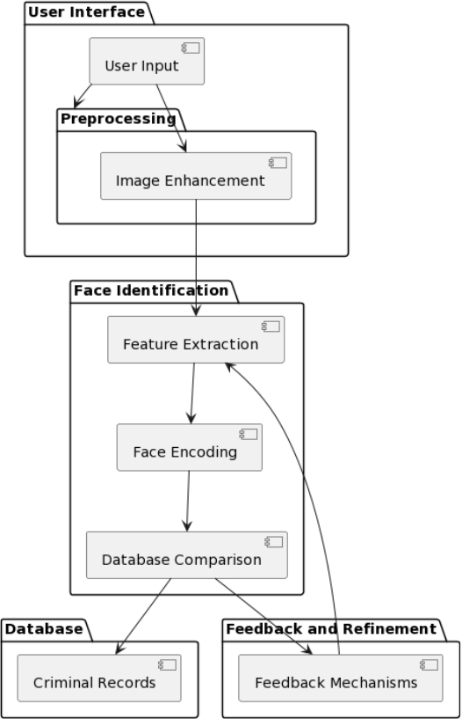

**Fig 4.1 Architecture**

**4.2.2 Data Flow Diagram:**

Data Flow Diagrams (DFDs) serve as a graphical tool for describing and analyzing the flow of data through a system, whether manual or automated. They provide a visual representation of how data moves through processes, stores, and delays within the system. DFDs are considered central to system analysis and design, serving as the foundation upon which other components are developed.

One of the key advantages of DFDs is their ability to depict the transformation of data from input to output through various processes, without being tied to the physical components of the system. This logical representation allows analysts to focus on the data flow and processing logic independently of hardware or software considerations.

Also referred to as data flow graphs or bubble charts, DFDs are instrumental in modeling the proposed system. They serve to clearly illustrate the requirements upon which the new system should be built. During the design phase, DFDs provide the basis for drawing the system's structure charts, which further delineate the system's architecture and components.

DFDs typically consist of several components, including external entities, processes, data stores, and data flows. External entities represent sources or destinations of data, processes depict transformations or operations performed on the data, data stores represent repositories for persistent data, and data flows indicate the movement of data between components.

The hierarchical nature of DFDs allows for the decomposition of complex systems into simpler, more manageable components. By breaking down the system into its constituent parts and illustrating the flow of data between them, DFDs facilitate a comprehensive understanding system functionality and requirements. This, in turn, aids in the development of effective system design that meet the needs of stakeholders and end-users.

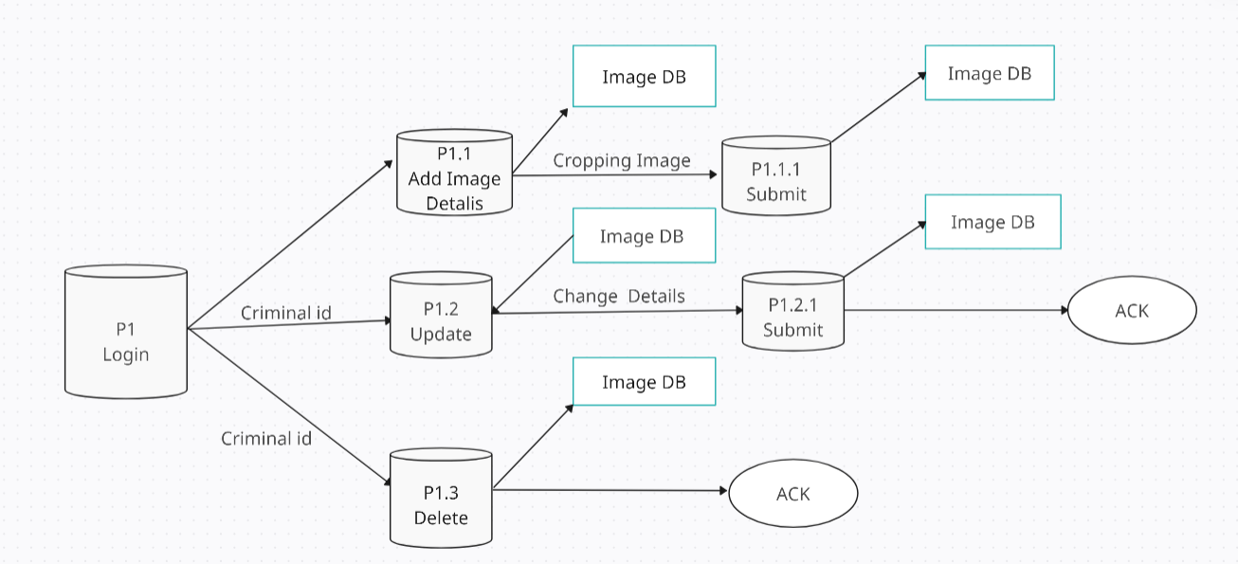 **Fig 4.2 Data Flow Diagram**

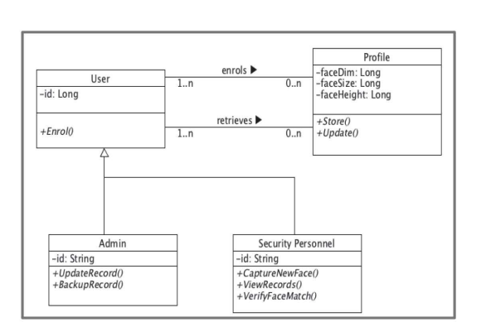**4.2.3 Class Diagram:**

**Fig 4.3 Class Diagram**

**4.2.4 Use case Diagram:**

In software engineering, a use case diagram serves as a pivotal tool in the Unified Modeling Language (UML), offering a graphical representation of a system's functionality in terms of actors, their goals (use cases), and any dependencies between these elements. It originates from and is created through Use-case analysis, providing a structured approach to understanding system behavior.

The primary objective of a use case diagram is to illustrate the functions performed by a system for various actors involved. Actors represent roles played by entities external to the system, such as users or external systems, while use cases depict specific functionalities or tasks performed by the system to fulfill the actors' goals.

Use case diagrams are integral components of two modeling languages standardized by the Object Management Group (OMG): UML and SysML. Both standards offer graphical notations for modeling use cases with diagrams, facilitating a clear visualization of system functionalities and actor interactions. However, a common criticism of these standards is the lack of a defined format for describing use cases, necessitating a combination of graphical notation and textual descriptions to fully document use cases.

By showcasing the relationships and dependencies between various use cases, a use case diagram provides context and organization to the system's functionality. It serves as an organizing mechanism, helping to promote a comprehensive understanding of system behavior among stakeholders, including customers, owners, users, and development teams. A well-defined set of coherent use cases fosters a shared understanding and facilitates effective communication between stakeholders, enhancing the overall success of the software development process.

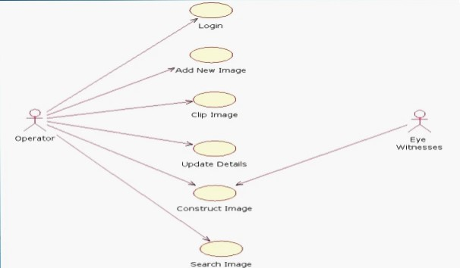

**Fig 4.4 Use Case Diagram**

**4.2.5 Sequence Diagram:**

Sequence diagrams in Unified Modeling Language (UML) serve as a powerful tool for visualizing and understanding the interactions between various processes or objects within a system. They provide a detailed depiction of how these processes operate with one another and in what specific order, helping to illustrate the flow of messages and actions during runtime scenarios.

At their core, sequence diagrams are a construct of Message Sequence Charts, enabling the graphical representation of interactions among different components of a system. They are also known by various names, including Event-trace diagrams, event scenarios, and timing diagrams.

The structure of a sequence diagram typically consists of parallel vertical lines, referred to as "lifelines," which represent different processes or objects within the system. These lifelines exist simultaneously and denote the entities involved in the interaction. Horizontal arrows, known as "messages," are then used to depict the exchange of messages or actions between these lifelines, illustrating the order in which they occur.

By visually mapping out the sequence of messages and actions between system components, sequence diagrams provide a clear and intuitive representation of runtime scenarios. They allow stakeholders to understand the dynamic behavior of the system and identify potential issues or bottlenecks in the interaction flow.

Sequence diagrams are particularly valuable during the design and analysis phases of software development. They help software architects and designers to visualize the expected behavior of the system, validate system requirements, and refine system designs. Additionally, sequence diagrams serve as effective communication tools, enabling developers to convey complex interaction patterns to team members, stakeholders, and clients in a clear and concise manner.

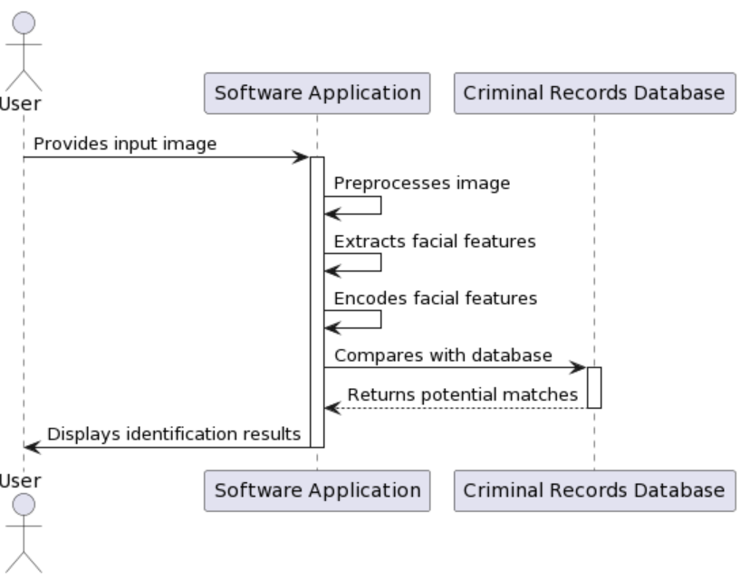

**Fig 4.5 Sequence Diagram**

**4.2.6 Activity Diagram:**

Activity diagrams serve as a versatile diagrammatic technique within the Unified Modeling Language (UML), offering a visual representation of stepwise workflows, actions, and activities within a system. They provide support for modeling complex processes, including choice, iteration, and concurrency, enabling software engineers and system designers to capture and communicate intricate operational workflows effectively.

In the context of UML, activity diagrams are instrumental in describing the business and operational workflows of system components. They offer a graphical depiction of the sequence of activities or actions performed within a system, illustrating the flow of control among various steps. By representing activities as nodes and transitions as edges between these nodes, activity diagrams provide a structured visualization of the system's behavior, facilitating comprehension and analysis.

Moreover, in the Systems Modeling Language (SysML), activity diagrams have been extended to incorporate flows among steps that convey physical elements or energy. This enhancement allows SysML activity diagrams to model not only abstract computational processes but also real-world phenomena involving physical elements such as gasoline or energy entities like torque and pressure. By incorporating these physical and energy flows into the diagram, SysML activity diagrams offer a comprehensive representation of system behaviors, including both computational and physical aspects.

By utilizing activity diagrams, system designers can effectively capture and communicate the workflows and interactions within a system, aiding in requirements analysis, system design, and implementation. These diagrams serve as valuable documentation artifacts, enabling stakeholders to visualize and understand the operational logic of a system, identify potential bottlenecks or inefficiencies, and make informed decisions regarding system design and optimization.

Overall, activity diagrams play a crucial role in system modeling and analysis, providing a clear and concise representation of complex workflows and activities. Whether used in UML or extended within SysML to incorporate physical and energy flows, activity diagrams serve as indispensable tools for capturing and communicating the operational essence of a system.

* **Administrator:**

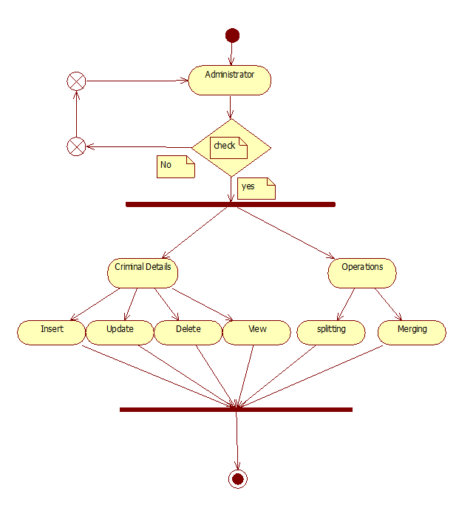

**Fig 4.6 Administrator**

* **Operator:**

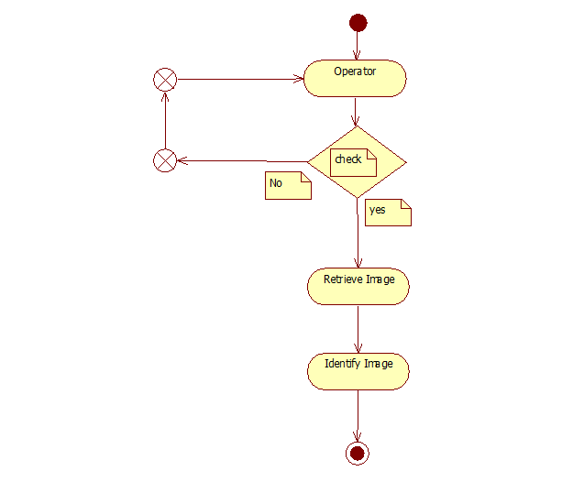

**Fig 4.7 Operator**

**4.2.7 Collaboration Diagram:**

Communication diagrams provide a visual representation of interactions between objects or components within a system, focusing on the sequence of messages exchanged between them. These diagrams combine elements from Class, Sequence, and Use Case Diagrams, offering insights into both the static structure and dynamic behavior of the system.

Unlike Sequence Diagrams, which depict interactions in a linear fashion, Communication Diagrams utilize a free-form arrangement of objects and links, akin to Object Diagrams. To maintain message sequencing in this free-form layout, messages are labeled with chronological numbers and positioned near the links over which they are sent. When interpreting a Communication Diagram, one typically starts at message 1.0 and follows the sequence of messages from object to object.

While Communication Diagrams and Sequence Diagrams convey similar information, they excel in presenting different aspects of system behavior. Communication diagrams excel in illustrating the elements with which each object interacts, offering clarity in the overall structure of interactions. On the other hand, Sequence Diagrams excel in depicting the precise order in which interactions occur, providing a clearer representation of message sequencing.

* **Administrator:**

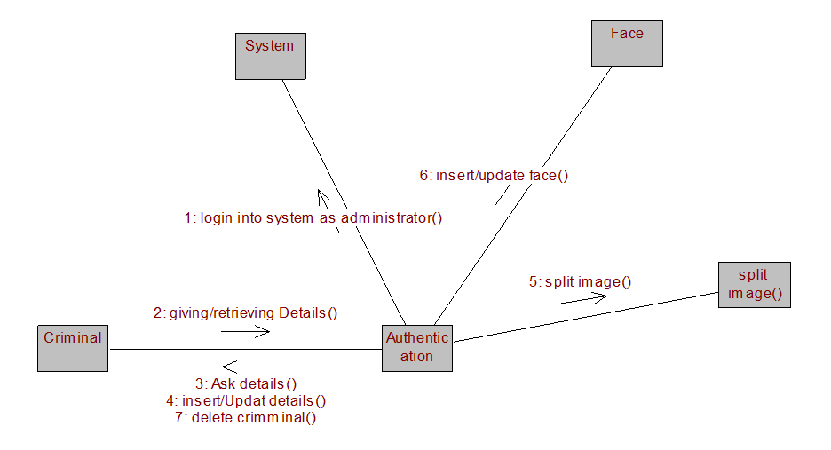

**Fig 4.8 Administrator**

* **Operator:**

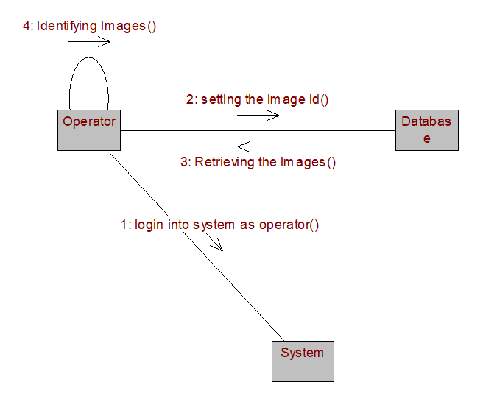

**Fig 4.9 Operator**

**CHAPTER 5**

**METHDOLOGIES**

**5.1 SDLC METHDOLOGIES**

The document outlining system requirements serves as a cornerstone in the software development life cycle (SDLC), playing a vital role in guiding developers and serving as a reference point throughout the development process. It comprehensively describes the complete set of requirements for the system, detailing its functionality, features, and specifications. This document serves as the foundation upon which the entire development process is built and is indispensable during the testing phase, where it is used to validate that the developed system meets the specified requirements.

Any changes to the requirements documented in this document are subject to a formal change approval process. This ensures that modifications are carefully considered, evaluated for their impact on the project, and approved by relevant stakeholders before implementation. By enforcing a structured change management process, the integrity and consistency of the project are maintained, minimizing the risk of scope creep and ensuring alignment with project objectives.

The Spiral Model, conceptualized by Barry Boehm in 1988, represents a significant milestone in software development methodologies. While iterative development approaches had been discussed previously, the Spiral Model was the first to provide a comprehensive framework for iterative development and enhancement. It introduced the concept of iterative cycles, or "spirals," each comprising phases of development, evaluation, and client feedback.

In the original formulation of the Spiral Model, iterations typically spanned from six months to two years. Each iteration begins with a defined design goal and concludes with a review session where the client evaluates the progress made thus far. Throughout each iteration, analysis and engineering efforts are applied iteratively, with a continuous focus on the end goal of the project.

The Spiral Model embodies a flexible and adaptive approach to software development, allowing for incremental refinement and improvement based on feedback from clients and stakeholders. By breaking the development process into iterative cycles, the model accommodates evolving requirements, changing priorities, and emerging challenges, fostering collaboration and innovation throughout the development lifecycle.

Key features of the Spiral Model include its emphasis on risk management, as each iteration includes risk analysis and mitigation strategies. Additionally, the model promotes collaboration and communication between development teams and clients, ensuring alignment with business objectives and user needs.

Overall, the Spiral Model provides a structured yet flexible framework for software development, enabling teams to navigate complex projects with agility and efficiency. Its iterative nature facilitates continuous improvement and adaptation, ultimately leading to the delivery of high-quality software that meets the needs of stakeholders and end-users.

The Spiral Model, characterized by its iterative and incremental approach to software development, consists of several generalized steps to guide the project from requirements definition to final system construction and maintenance.

* **Requirements Definition:** The process begins with a comprehensive definition of the new system requirements, involving interviews with users and stakeholders to gather detailed insights into their needs and expectations.
* **Preliminary Design:** A preliminary design is formulated based on the defined requirements, outlining the overall structure and functionality of the new system.
* **First Prototype Construction:** A scaled-down prototype of the system is developed based on the preliminary design, providing an initial approximation of the final product's characteristics.
* **Second Prototype Evolution:**
* **Evaluation:** The first prototype is evaluated to identify strengths, weaknesses, and risks associated with its implementation.
* **Requirements Definition**: Based on the evaluation, requirements for the second prototype are refined and specified.
* **Planning and Design:** The design for the second prototype is planned and developed, incorporating feedback from the evaluation phase.
* **Construction and Testing:** The second prototype is constructed and rigorously tested to validate its functionality and address any identified issues.
* **Risk Assessment and Project Continuation:** At this stage, the customer has the option to abort the project if deemed necessary due to significant risks such as cost overruns or operational miscalculations.
* **Prototype Evaluation and Iteration:** The existing prototype undergoes evaluation, and if required, further iterations are carried out to refine the system based on feedback from stakeholders.
* **Customer Satisfaction:** Iterations continue until the customer is satisfied that the refined prototype aligns with their desired final product.
* **Final System Construction:** Once the refined prototype meets the customer's satisfaction, the final system is constructed based on the prototype's specifications.
* **Thorough Evaluation and Testing:** The final system undergoes thorough evaluation and testing to ensure its functionality, reliability, and performance meet the desired standards.
* **Routine Maintenance:** Ongoing routine maintenance is conducted to prevent large-scale failures and minimize downtime, ensuring the system's continued operation and effectiveness.

Through these iterative cycles, the Spiral Model allows for continuous refinement and improvement of the system, ultimately leading to the development of a high-quality product that meets the needs of stakeholders and end-users.

**The following diagram shows how a spiral model acts like:**

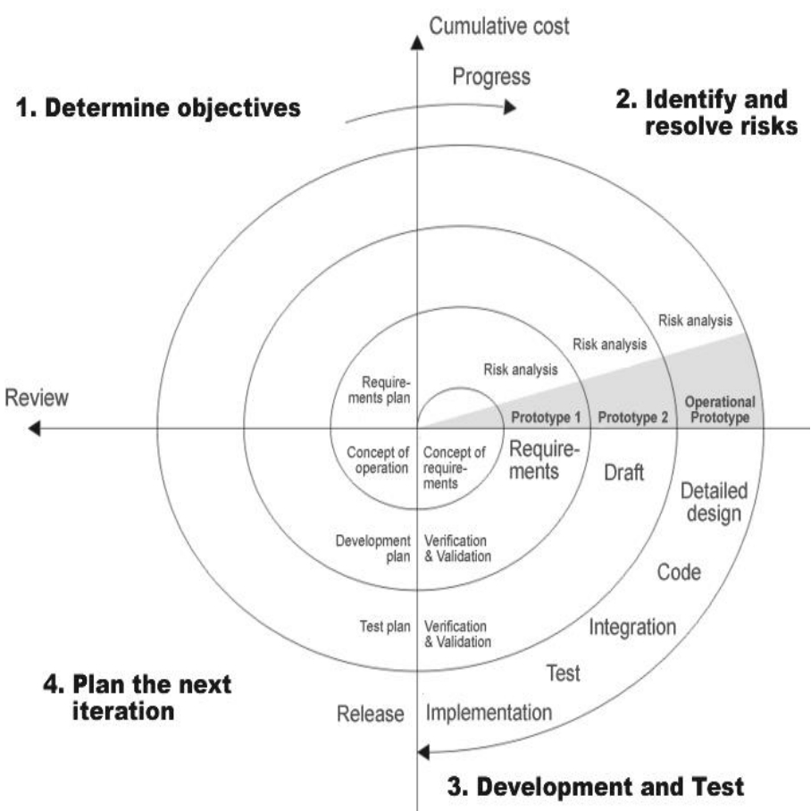

**Fig 5.1 Spiral Model**

**5.2 Advantages:**

The Spiral Model offers several advantages that make it an attractive choice for software development projects:

* **Realistic Estimates:** As the project progresses through iterative cycles, estimates for budget, schedule, and other project aspects become more accurate and realistic. Early identification of issues allows for better planning and allocation of resources, reducing the likelihood of budget and schedule overruns.
* **Change Management:** The Spiral Model is well-suited to accommodate changes inherent in software development. By breaking the project into iterative cycles, it allows for flexibility and adaptability to evolving requirements, technology advancements, and stakeholder feedback. This reduces the risk of project failure due to inflexible planning and enables the team to respond effectively to changes throughout the development process.
* **Early Project Initiation:** The Spiral Model enables software engineers to commence work on the core components of the project at an early stage. Since the development process begins with a preliminary design and the construction of a prototype, developers can start working on essential aspects of the project sooner. This early initiation facilitates rapid progress and ensures that critical functionality is implemented early in the development lifecycle.

**5.3 Application Development:**

**5.3.1 N-Tier Applications:**

N-Tier Applications offer significant advantages when it comes to implementing Distributed Application Design and Architecture. Unlike 2-tier client-server systems, which may suffice for rapid prototyping but can pose maintenance and security challenges, N-Tier Applications provide strategic benefits that are crucial for enterprise solutions.

**Key advantages of N-Tier Applications include:**

* **Security:** N-Tier Applications offer robust security features, allowing for the implementation of granular access controls, encryption, and authentication mechanisms at various layers. This ensures the protection of sensitive data and mitigates the risk of unauthorized access or data breaches.
* **Availability and Scalability:** By distributing functionality across multiple tiers, N-Tier Applications can enhance availability and scalability. Load balancing and resource allocation across tiers enable the system to handle increasing user loads and accommodate growth without sacrificing performance.
* **Manageability:** The modular structure of N-Tier Applications facilitates easier management and administration. Each tier can be managed independently, allowing for seamless updates, maintenance, and troubleshooting without disrupting the entire system.
* **Easy Maintenance:** N-Tier Applications promote code reusability and separation of concerns, making maintenance tasks more manageable. Updates or modifications to specific tiers can be implemented without affecting other components, reducing the risk of unintended consequences and minimizing downtime.
* **Data Abstraction:** N-Tier Applications abstract data access and manipulation, enabling a clean separation between the presentation layer, business logic layer, and data access layer. This abstraction enhances flexibility, interoperability, and the ability to integrate with diverse data sources and systems.

**5.3.2 Definition:**

An N-Tier application is a software architecture that distributes the overall functionality of an application into separate tiers or layers, each responsible for specific tasks. This architectural approach organizes the application's components in a structured manner, facilitating modular development, maintenance, and scalability. The key tiers in an N-Tier application typically include the Presentation Layer, Business Rules Layer, Data Access Layer, and Database or Data Store.

* **Presentation Layer:** The Presentation Layer is responsible for interacting with users and presenting data in a human-readable format. This layer handles user input, displays information, and collects user actions. It includes components such as user interfaces, web pages, or mobile app interfaces. By separating the presentation logic from other layers, developers can focus on creating intuitive and responsive user experiences without being concerned about underlying business logic or data access.
* **Business Rules Layer:** The Business Rules Layer contains the core logic and rules that govern the behaviour of the application. It encapsulates business logic, validation rules, and workflow processes, ensuring consistency and integrity in data processing and manipulation. This layer serves as the bridge between the Presentation Layer and the Data Access Layer, orchestrating the flow of data and operations within the application. By isolating business rules, developers can maintain and update them independently of other layers, promoting code reusability and modularity.
* **Data Access Layer:** The Data Access Layer is responsible for interacting with the underlying data storage systems, such as databases or external APIs. It encapsulates data access logic, including querying, retrieving, updating, and deleting data from the data store. This layer abstracts the complexities of data storage and retrieval, providing a unified interface for the Business Rules Layer to interact with data sources. By separating data access concerns from business logic, developers can ensure flexibility, scalability, and security in data management operations.
* **Database or Data Store:** The Database or Data Store represents the underlying storage mechanism where application data is persisted. It can be a relational database, NoSQL database, file system, or any other data storage solution. The Data Access Layer communicates with the database to perform CRUD (Create, Read, Update, Delete) operations and maintain data integrity. By decoupling the database from other layers, developers can easily switch between different data storage technologies or scale the system to accommodate growing data volumes.

One of the primary advantages of an N-Tier application architecture is the encapsulation of functionality within each layer. Each layer operates as a "Black Box," meaning it treats other layers as independent modules and communicates with them through well-defined interfaces or APIs. This modular design promotes loose coupling between layers, enabling developers to modify, replace, or extend individual layers without impacting the overall system functionality. Additionally, the division of responsibilities among layers simplifies development, testing, and maintenance efforts, leading to more robust, scalable, and maintainable software solutions. Overall, an N-Tier application architecture provides a structured and flexible framework for building complex, enterprise-grade applications while promoting code organization, reusability, and ease of maintenance.

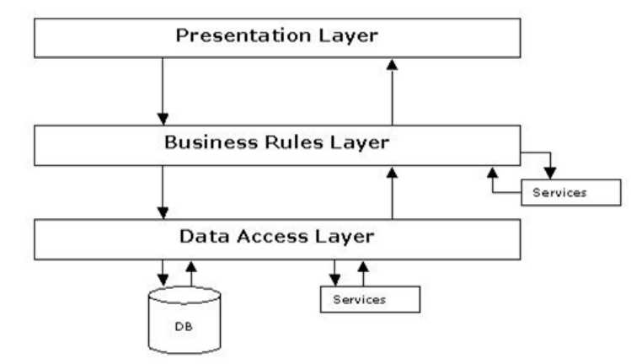

**Fig 5.2 N-Tier Architecture**

**5.3.3 Steps for Method:**

The facial recognition process involves several distinct steps, each contributing to the accurate identification of individuals:

1. **Image Input:**Receive input images from various sources such as surveillance cameras or eyewitness accounts.
2. **Preprocessing:**Enhance image quality through preprocessing techniques like noise reduction and normalization.
3. **Feature Extraction:**Extract key facial features from pre-processed images, such as eyes, nose, and mouth.
4. **Face Encoding:**Encode extracted facial features into a format suitable for comparison with other facial encodings.
5. **Database Comparison:**Compare encoded facial features with a database of known faces, such as a criminal records database or a watchlist.
6. **Matching and Identification:**Identify potential matches between input images and faces in the database.

**5.3.4 Algorithm**

The algorithm for facial recognition involves several sequential steps aimed at identifying individuals based on their facial features:

1. **Initialize:** Start the facial recognition system.
2. **Preprocess Criminal Record:** Extract facial features from the criminal's photograph and store them in the database along with personal information.
3. **Process Image Segments:** For each low-resolution image segment: Preprocess the segment. - Extract facial features from the segment.
4. **Search Database:** Compare the extracted features with those in the database.Calculate Similarity: Calculate a similarity score between the extracted features and those in the database.
5. **Check for Match:** If the similarity score is above a predefined threshold: Output the matched criminal's personal information. Display the criminal's photograph.
6. **No Match Found:** If no match is found after searching through the entire database, output "No match found”.
7. **End:** End the algorithm

**CHAPTER 6**

**SYSTEM DESIGN**

During the system design stage of software development, the focus shifts from what needs to be accomplished to how the problem will be solved, albeit at a high level. This stage marks the initial phase where decisions are made regarding the overall structure and style of the system. System design encompasses the selection of the basic approach to problem-solving and the establishment of the system architecture, which serves as the foundation for subsequent design decisions.

At the heart of system design lies the organization of the system into subsystems. These subsystems are modular components that collectively form the architecture of the system. The system designer must strategically partition the problem into these subsystems, enabling further development work to be carried out independently by different teams or designers.

Furthermore, the system designer must address various aspects inherent in the problem, including concurrency and task allocation. Concurrency refers to the simultaneous execution of multiple tasks or processes within the system, necessitating careful consideration to ensure efficient resource utilization and system responsiveness. Task allocation involves assigning subsystems to processors or tasks, optimizing system performance and resource utilization.

Another critical decision during system design pertains to the management of data stores. This includes determining the approach for storing and accessing data within the system, such as database management systems or file storage mechanisms. Effective management of data stores is essential for ensuring data integrity, security, and accessibility.

Additionally, the system designer must address concerns related to access to global resources, control implementation, and handling boundary conditions. Access to global resources involves managing shared resources across subsystems, while control implementation focuses on defining the mechanisms for governing system behavior and flow. Handling boundary conditions entails managing interactions between the system and its external environment, ensuring robustness and reliability.

Moreover, system designers must make trade-off decisions, prioritizing certain aspects of system design over others based on project constraints, requirements, and objectives. These trade-offs may involve considerations such as performance, scalability, maintainability, and cost-effectiveness.

The system designer must make the following decisions:

* Organize the system into subsystems.
* Identify the concurrency inherent in the problem.
* Allocate subsystems to processors and tasks.
* Choose an approach for management of data stores.
* Handle access to global resources.
* Choose the implementation of control in software.
* Handle boundary conditions.
* Set trade-off priorities.

**6.1 Breaking the System into Subsystems:**

In system design, the process begins with dividing the system into smaller, manageable components known as subsystems. Each subsystem encapsulates specific aspects of the system, such as functionality, physical location, or hardware execution. Subsystems are not merely objects or functions; rather, they are packages comprising classes, associations, operations, events, and constraints that are interrelated and possess a well-defined interface with other subsystems.

Subsystems are identified based on the services they provide, which are groups of related functions sharing a common purpose. This allows for a coherent approach to addressing different aspects of the problem. Each subsystem maintains a clear interface with the rest of the system, specifying the form of interactions and information flow across subsystem boundaries while allowing for independent internal implementation.

System decomposition into subsystems may follow either a horizontal layering or vertical partitioning approach. In a layered system, subsystems are organized into ordered sets of virtual worlds, each built upon the ones below it and providing the basis for implementation of those above it. Layered architecture can be closed or open, depending on the extent to which layers can use features from lower layers.

For instance, our system is decomposed into three layers: GUI layer, Network layer, and I/O layer, following a closed architecture form. The GUI layer offers an efficient user interface for system interaction, built upon the Network layer providing basic FTP services, with the lowest layer being the I/O layer facilitating file reading and writing between local and remote systems.

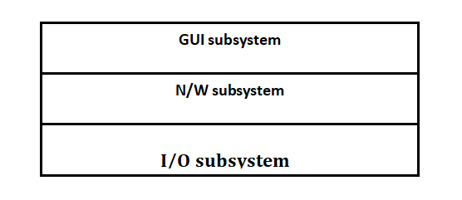

**Fig 6.1 Subsystem**

Once top-level subsystems are identified, the information flow among them is illustrated, often within established architectural frameworks like batch transformation, continuous transformation, and interactive interface. Our system aligns with the interactive interface architecture, characterized by a significant number of interactions between the system and external agents such as humans, devices, or other programs. In this architecture, the system engages in frequent interactions with external agents, though it cannot control their inputs, as they remain independent entities whose responses may be solicited by the system.

**6.2 Identifying Concurrency:**

In system design, it's crucial to determine which objects require concurrent activity and which ones have mutually exclusive actions. Concurrent objects perform tasks simultaneously, while mutually exclusive objects perform actions that cannot occur simultaneously and can be executed sequentially within a single thread of control or task. However, in our system, there are no components or processes that necessitate concurrent execution.

Given the nature of the system, which involves sequential processing of facial recognition tasks, there are no inherent requirements for concurrent activity. The system operates in a linear fashion, where each step, such as image preprocessing, feature extraction, and database comparison, occurs sequentially without overlapping or parallel execution. As a result, there is no need to identify concurrent objects or implement concurrent processing mechanisms within the system architecture.

Instead, the focus remains on ensuring efficient sequential execution of tasks and effective coordination between different components to achieve the desired functionality and performance. By recognizing the absence of concurrent requirements, the system design can streamline its architecture and optimize resource utilization for sequential processing, thereby simplifying the overall design and implementation process.

**6.3 Allocating Subsystems to Processor:**

In this phase of system design, the system designer assesses the hardware resources necessary for implementation and decides whether to implement the subsystems using hardware or software solutions. In our system, all subsystems will be implemented in software, indicating that hardware requirements will primarily focus on supporting the software implementation.

The hardware requirements for our system are relatively standard, with specifications such as a Pentium III processor and 128 MB of RAM. These requirements are sufficient to support the execution of software components and processes involved in facial recognition, including image preprocessing, feature extraction, database comparison, and result output.

By opting for a software-based implementation, the system can leverage the flexibility and scalability offered by software solutions, allowing for easier maintenance, updates, and modifications as needed. Additionally, software implementation eliminates the need for specialized hardware components, reducing overall system costs and complexity.

**6.4 Management of Data Stores:**

In this stage, the system designer determines the format for storing data within the system. In our project, where no formal database management system (DBMS) is required, we opt for file storage as the primary data storage solution. Files provide a straightforward method for downloading and uploading data, making them well-suited for our needs. By utilizing files, we ensure simplicity in data management and accessibility, eliminating the need for complex database structures. This choice aligns with the project's requirements, facilitating efficient storage and retrieval of information without the overhead of a DBMS.

**6.5 Choosing Software Control Implementation:**

During analysis, system interactions are depicted as events between objects, yet the system designer must determine the software's control implementation. Control flows in software systems can be categorized into internal and external. External control involves the flow of externally visible events among system objects. External control can be procedure-driven, event-driven sequential, or concurrent. Internal control, on the other hand, concerns the flow of control within a process.

Our system aligns with external control flow, specifically event-driven control. External events, triggered by external agents like users, dictate the system's behaviour. However, events occur sequentially rather than concurrently. This means that events are handled in the order they are received, ensuring a sequential flow of execution within the system. By adopting event-driven control, our system efficiently manages interactions with external agents while maintaining a structured and predictable execution flow.

**CHAPTER 7**

**TECHNOLOGY DESCRIPTION**

**7.1 FEATURES OF THE LANGUAGE USED:**

**7.1.1 About Java:**

Initially the language was called as “oak” but it was renamed as “Java” in 1995. The primary motivation of this language was the need for a platform-independent (i.e., architecture neutral) language that could be used to create software to be embedded in various consumer electronic devices.

* Java is a programmer’s language.
* Java is cohesive and consistent.
* Except for those constraints imposed by the Internet environment, Java gives the programmer, full control.

Finally, Java is to Internet programming where C was to system programming.

**7.1.2 Swings:**

Swing, an extension library to AWT, enriches GUI development with its advanced components and functionalities. It empowers developers to craft standalone Swing GUI Apps, Servlets, and Applets, offering enhanced aesthetics and usability. Employing a model/view architecture, Swing provides greater portability and flexibility compared to AWT.

As Swing is built atop AWT and fully implemented in Java, it leverages AWT's lightweight component support while introducing new features and improvements. Its architecture facilitates easy customization of both appearance and behavior of components, enabling developers to create tailored user interfaces. Moreover, Swing seamlessly integrates with AWT, allowing the blending of Swing components with existing AWT-based applications. This interoperability enables the utilization of Swing's advanced components alongside standard AWT elements, fostering versatility in GUI design.

For instance, Swing components like JSlider, JButton, and JCheckbox can coexist harmoniously with conventional AWT labels, text fields, and scroll bars within the same application. Developers can extend Swing's UI, model, or change listener classes without reimplementing the entire system, thus enhancing development efficiency and maintainability. Additionally, Swing offers dynamic object replacement capabilities, enabling runtime modifications to UI components.

Overall, Swing's comprehensive feature set, seamless integration with AWT, and adaptability make it a preferred choice for developing rich and interactive GUI applications in Java. Its versatility and extensibility empower developers to create visually appealing and highly functional user interfaces across various Java platforms.

**7.1.3 Java Swing class hierarchy:**

The class JComponent, descended directly from Container, is the root class for most of Swing’s user interface components.

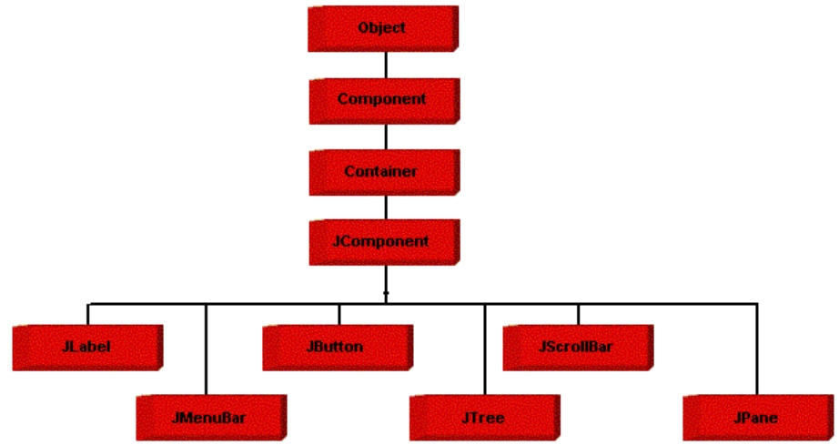

**Fig 7.1 Java Swing class hierarchy**

Swing contains components that you’ll use to build a GUI. I am listing you some of the commonly used Swing components. To learn and understand these swing programs, AWT Programming knowledge **is not** required.

**7.1.4 Java Swing class hierarchy**

**Security**

Every time you that you download a “normal” program, you are risking a viral infection. Prior to Java, most users did not download executable programs frequently, and those who did scan them for viruses prior to execution. Most users still worried about the possibility of infecting their systems with a virus. In addition, another type of malicious program exists that must be guarded against. This type of program can gather private information, such as credit card numbers, bank account balances, and passwords. Java answers both of these concerns by providing a “firewall” between a networked application and your computer. When you use a Java-compatible Web browser, you can safely download Java applets without fear of virus infection or malicious intent.

**Portability**

For programs to be dynamically downloaded to all the various types of platforms connected to the Internet, some means of generating portable executable code is needed .As you will see, the same mechanism that helps ensure security also helps create portability. Indeed, Java’s solution to these two problems is both elegant and efficient.

**The Byte code:**

The key that allows the Java to solve the security and portability problem is that the output of Java compiler is Byte code. Byte code is a highly optimized set of instructions designed to execute by the Java run-time system, which is called the Java Virtual Machine (JVM). That is, in its standard form, the JVM is an interpreter for byte code.

Translating a Java program into byte code helps makes it much easier to run a program in a wide variety of environments. The reason is, once therun-time package exists for a given system, any Java program can run on it.

Although Java was designed for interpretation, there is technically nothing about Java that prevents on-the-fly compilation of byte code into native code. Sun has just completed its Just In Time (JIT) compiler for byte code. When the JIT compiler is a part of JVM, it compiles byte code into executable code in real time, on a piece-by-piece, demand basis. It is not possible to compile an entire Java program into executable code all at once, because Java performs various run-time checks that can be done only at run time. The JIT compiles code, as it is needed, during execution.

Java Virtual Machine (JVM)

Beyond the language, there is the Java virtual machine. The Java virtual machine is an important element of the Java technology. The virtual machine can be embedded within a web browser or an operating system. Once a piece of Java code is loaded onto a machine, it is verified. As part of the loading process, a class loader is invoked and does byte code verification makes sure that the code that’s has been generated by the compiler will not corrupt the machine that it’s loaded on. Byte code verification takes place at the end of the compilation process to make sure that is all accurate and correct. So byte code verification is integral to the compiling and executing of Java code.

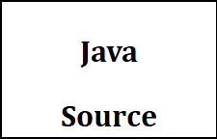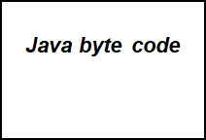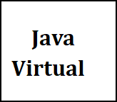



**.Java .Class**

**Fig 7.2 JVM**

The above picture shows the development process a typical Java programming uses to produce byte codes and executes them. The first box indicates that the Java source code is located in a. Java file that is processed with a Java compiler called **JAVA**. The Java compiler produces a file called a. class file, which contains the byte code. The class file is then loaded across the network or loaded locally on your machine into the execution environment is the Java virtual machine, which interprets and executes the byte code.

**Java Architecture**

Java architecture provides a portable, robust, high performing environment for development. Java provides portability by compiling the byte codes for the Java Virtual Machine, which is then interpreted on each platform by the run-time environment. Java is a dynamic system, able to load code when needed from a machine in the same room or across the planet.

**Compilation of Code**

When you compile the code, the Java compiler creates machine code (called byte code) for a hypothetical machine called Java Virtual Machine (JVM). The JVM is supposed to execute the byte code. The JVM is created for overcoming the issue of portability. The code is written and compiled for one machine and interpreted on all machines. This machine is called Java Virtual Machine. Compiling and interpreting Java Source Code

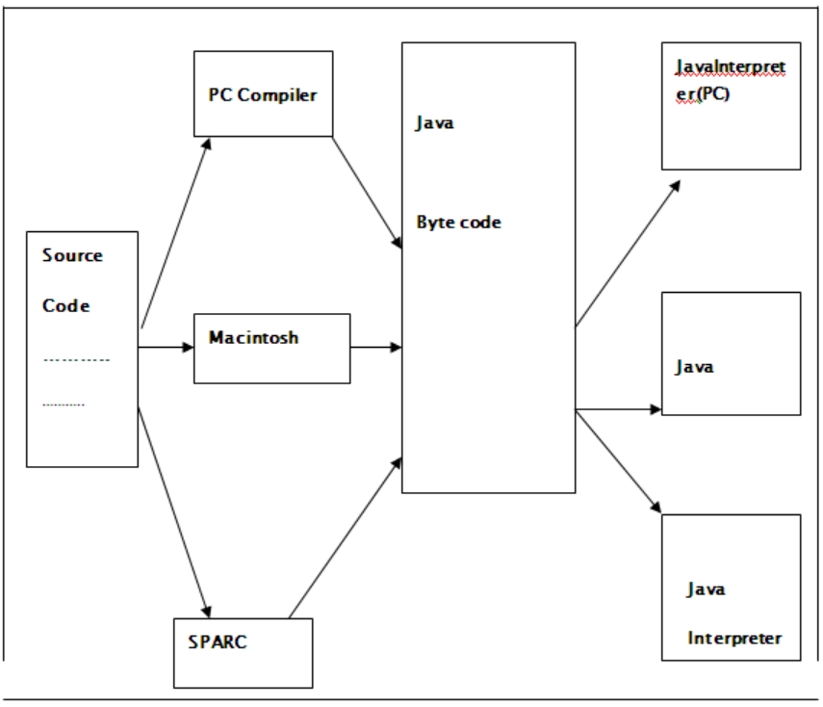

**Fig 7.3 Compilation of Code**

During run-time the Java interpreter tricks the byte code file into thinking that it is running on a Java Virtual Machine. In reality this could be a Intel Pentium Windows 95 or Suns ARC station running Solaris or Apple Macintosh running system and all could receive code from any computer through Internet and run the Applets.

**SIMPLE**

Java was designed to be easy for the Professional programmer to learn and to use effectively. If you are an experienced C++ programmer, learning Java will be even easier. Because Java inherits the C/C++ syntax and many of the object-oriented features of C++. Most of the confusing concepts from C++ are either left out of Java or implemented in a cleaner, more approachable manner. In Java there are a small number of clearly defined ways to accomplish a given task.

## **Object-Oriented:**

Java was not designed to be source-code compatible with any other language. This allowed the Java team the freedom to design with a blank slate. One outcome of this was a clean usable, pragmatic approach to objects. The object model in Java is simple and easy to extend, while simple types, such as integers, are kept as high-performance non-objects.

**Robust:**

The multi-platform environment of the Web places extraordinary demands on a program, because the program must execute reliably in a variety of systems. The ability to create robust programs was given a high priority in the design of Java. Java is strictly typed language; it checks your code at compile time and run time. Java virtually eliminates the problems of memory management and de-allocation, which is completely automatic. In a well-written Java program, all run time errors can –and should –be managed by your program.

**CHAPTER 8**

**Implementation & Testing**

**8.1 Code**

import java.awt.*;

Import java.awt.event.*;

Import javax.swing.*;

public class Operator extends JFrame implements ActionListener

{

Label l,l3;

JLabel l2,l1;

Font f;

Button b1,b2,b3,b4,b5,b8,b9,b10;

Container c1;

Operator()

{

c1=getContentPane();

c1.setLayout(new FlowLayout());

setBackground(Color.LIGHT_GRAY);

f=new Font("Arial",Font.BOLD,20);

setFont(f);

ImageIcon i=new ImageIcon("criminal1.jpg");

l=new Label(" Welcome Chandu!!!!!!!! ");

l2=new JLabel(" Hi, ",i,JLabel.LEADING);

l3=new Label(" This is Operator", Label.CENTER);

b3=new Button("Identifying of Images ");

b4=new Button("Images from Data Base");

b5=new Button("Images from Eyewitnesses");

b8=new Button("Drawing of Images");

b9=new Button(" Matching of Images")

b10=new Button("Data to Administrator");

addWindowListener(new WindowAdapter()

{

public void window Closing(WindowEvent e)

{

System.exit(0);

}

});

l.setForeground(new Color(100,100,100));

l.setFont(new Font("Arial",Font.BOLD,30));

l2.setForeground(new Color(100,100,100));

l2.setFont(new Font("Arial",Font.BOLD,20));

l3.setForeground(new Color(0,64,64));

l3.setFont(new Font("Arial",Font.BOLD,20));

b3.setForeground(new Color(255,255,255));

b3.setBackground(new Color(0,64,64));

b3.setFont(new Font("Arial",Font.BOLD,15));

b4.setForeground(new Color(255,255,255));

b4.setFont(new Font("Arial",Font.BOLD,15));

b4.setBackground(new Color(0,64,64));

b5.setForeground(new Color(255,255,255));

b5.setFont(new Font("Arial",Font.BOLD,15));

b5.setBackground(new Color(0,64,64));

b8.setForeground(new Color(255,255,255));

b8.setFont(new Font("Arial",Font.BOLD,15));

b8.setBackground(new Color(0,64,64));

b9.setForeground(new Color(255,255,255));

b9.setFont(new Font("Arial",Font.BOLD,15));

b9.setBackground(new Color(0,64,64));

b10.setForeground(new Color(255,255,255));

b10.setFont(new Font("Arial",Font.BOLD,15));

b10.setBackground(new Color(0,64,64));

b3.addActionListener(this);

b4.addActionListener(this);

//b5.addActionListener(this);

b8.addActionListener(this);

//b10.addActionListener(this);

//b9.addActionListener(this);

c1.add(l);

c1.add(l2);

c1.add(l3);

// c1.add(b5);

c1.add(b4);

c1.add(b3);

c1.add(b8);

// c1.add(b9);

// c1.add(b10);

setSize(500,600);

setVisible(true);

}

public void actionPerformed(ActionEvent ae)

{

if(ae.getSource()==b5)

{

Insert1 d=new Insert1();

d.setSize(700,600);

d.setVisible(true);

}

if(ae.getSource()==b3)

{

System.out.println("Face Framing page opening");

faceIdMain1 f1=new faceIdMain1();

f1.setSize(800,800);

f1.setVisible(true);

}

if(ae.getSource()==b8)

{

Draw d1=new Draw();

d1.setSize(600,400);

d1.setVisible(true);

}

if(ae.getSource()==b9)

{

MatchingImg mi=new MatchingImg();

mi.setSize(700,600);

mi.setVisible(true);

}

if(ae.getSource()==b10)

{

DatafromOp da=new DatafromOp();

da.setSize(600,400);

da.setVisible(true);

}

if(ae.getSource()==b4)

{

Retr r1=new Retr();

r1.setSize(600,600);

r1.setVisible(true);

}

}

public static void main(String args[])

{

Operator op= new Operator();

}}

**8.2 Execution Flow:**

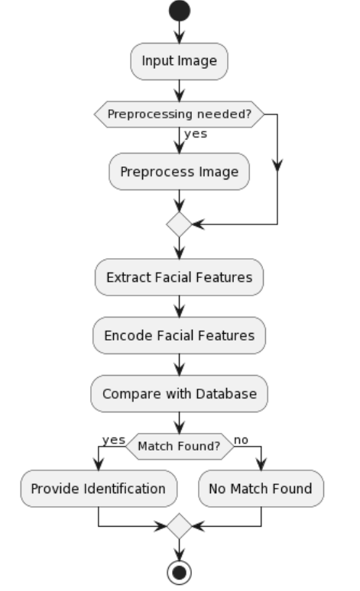

**Fig 8.1 Execution Flow**

**8.3 Testing:**

### **8.3.1 Test case 1**

Use Case: download a file.

Background: User wants to download a file from Criminal Face Identification System

Event Sequence:

1. Select file to download in remote tree panel.
2. Right click and then click download.

### **8.3.2 Test case 2:**

Use Case : upload a file.

Background : User wants to upload a file to the server from client.

Event Sequence:

1. Click file in local file view tree.
2. Right click and select upload.

### **8.3.3 Test case 3:**

Use Case : Remove file on remote server.

Background : User wants to delete a file on the server.

Event Sequence:

1. Select file on remote file view tree panel.
2. Right click and select ‘Delete’.

### **8.3.4 Test case 4:**

Use Case : Disconnect to server.

Background : User wants to close the session.

Event Sequence:

1. Click disconnect option in menu

In this way we tested using different test cases that found lot of errors which were corrected by recoding of that related procedures.

**CHAPTER 9**

**Results**

**9.1 Resulting Screen:**

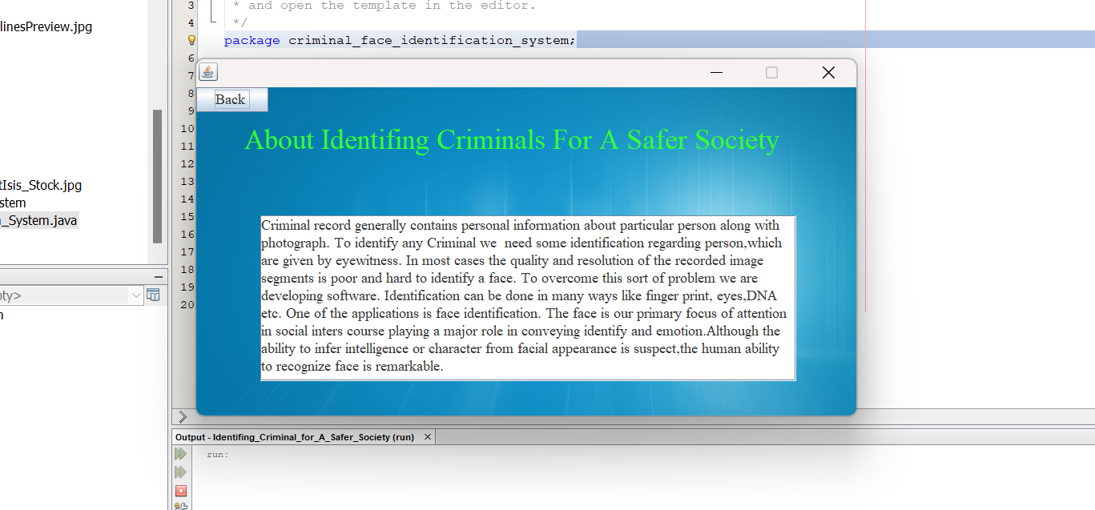

**Fig 9.1 Home Page Layout**

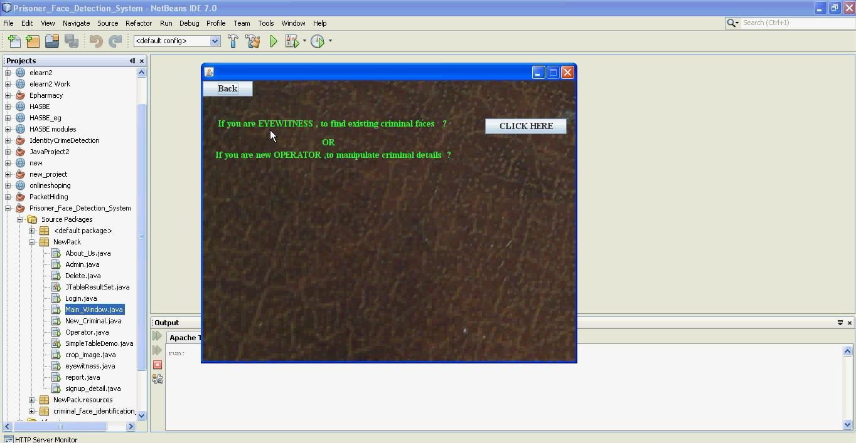

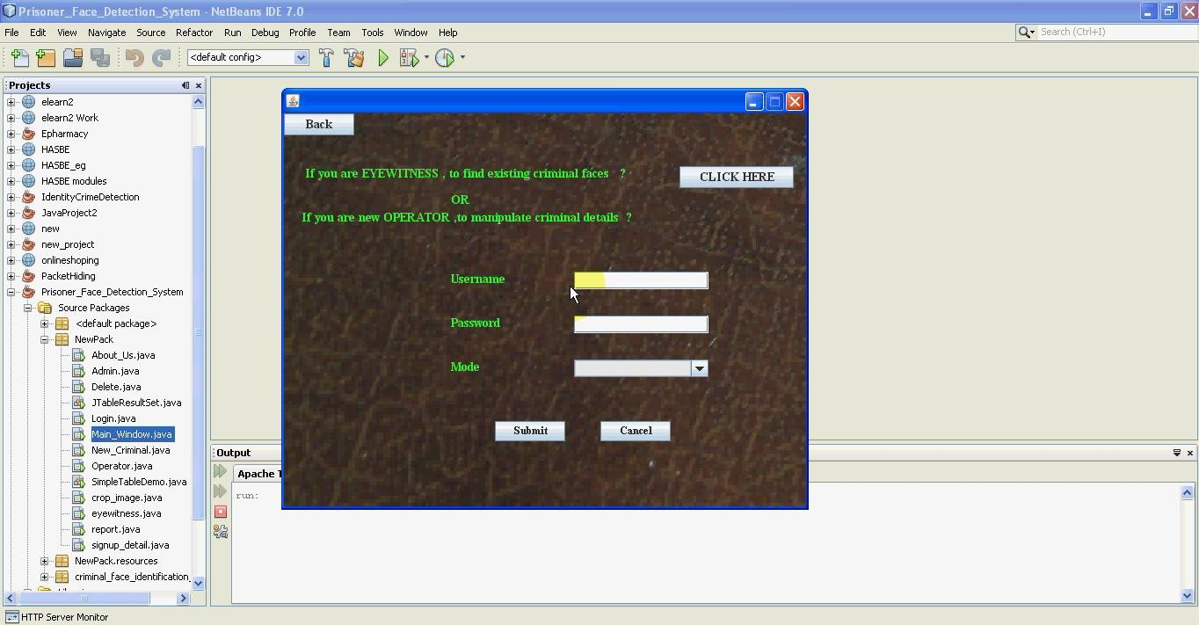 **Fig 9.2 Sign-up Page**

**Fig 9.3 User Sing-Up Page**

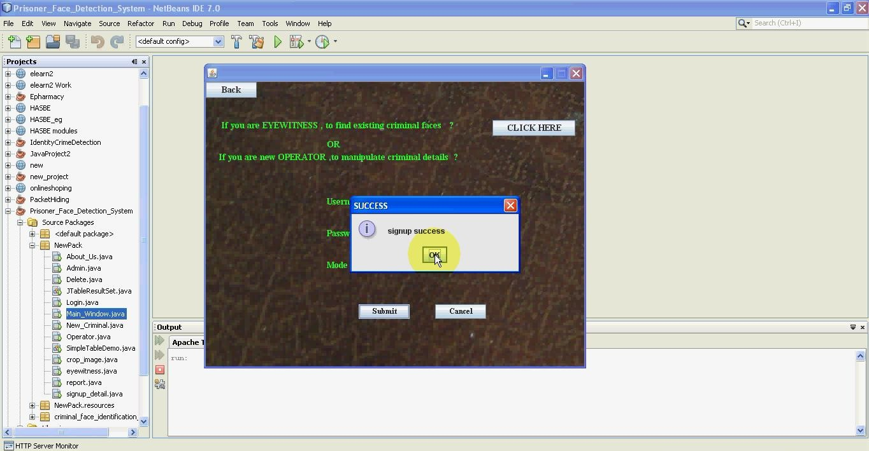**Fig 9.4 Sing-Up Success**

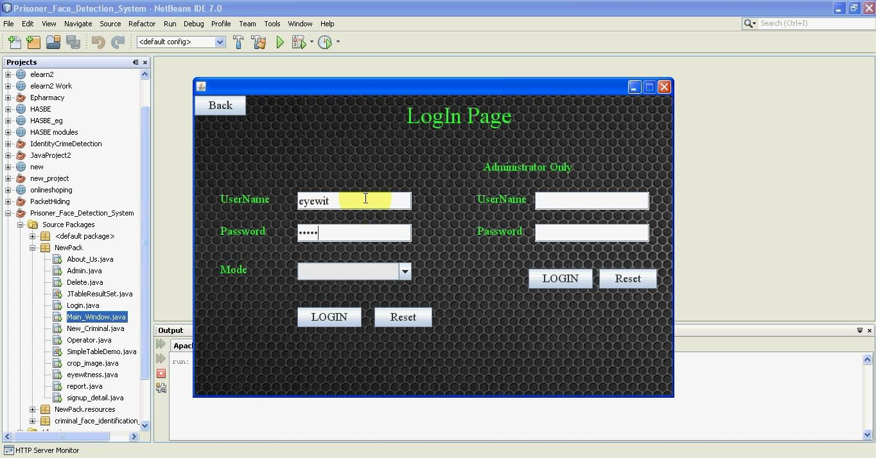

**Fig 9.5 Sing-In Page**

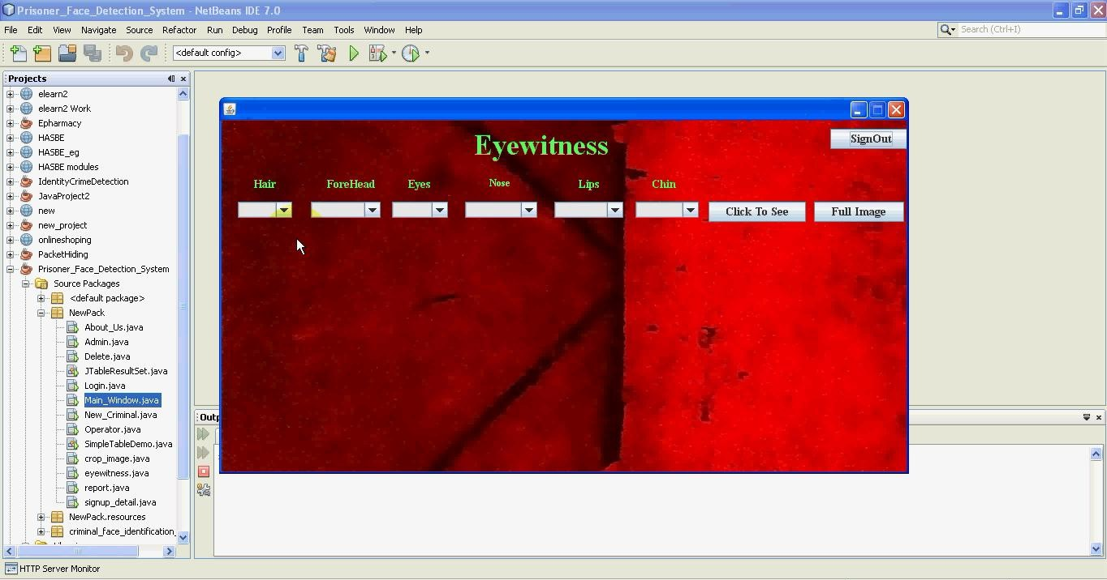

**Fig 9.6 Eyewitness page**

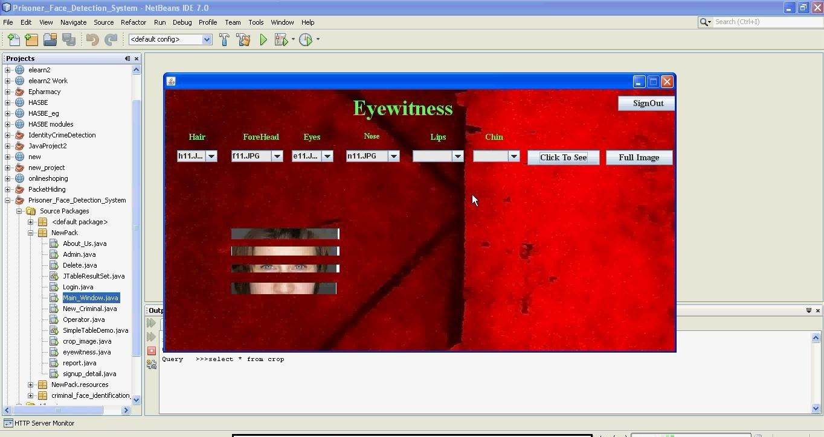

**Fig 9.7 Image Selection Page**

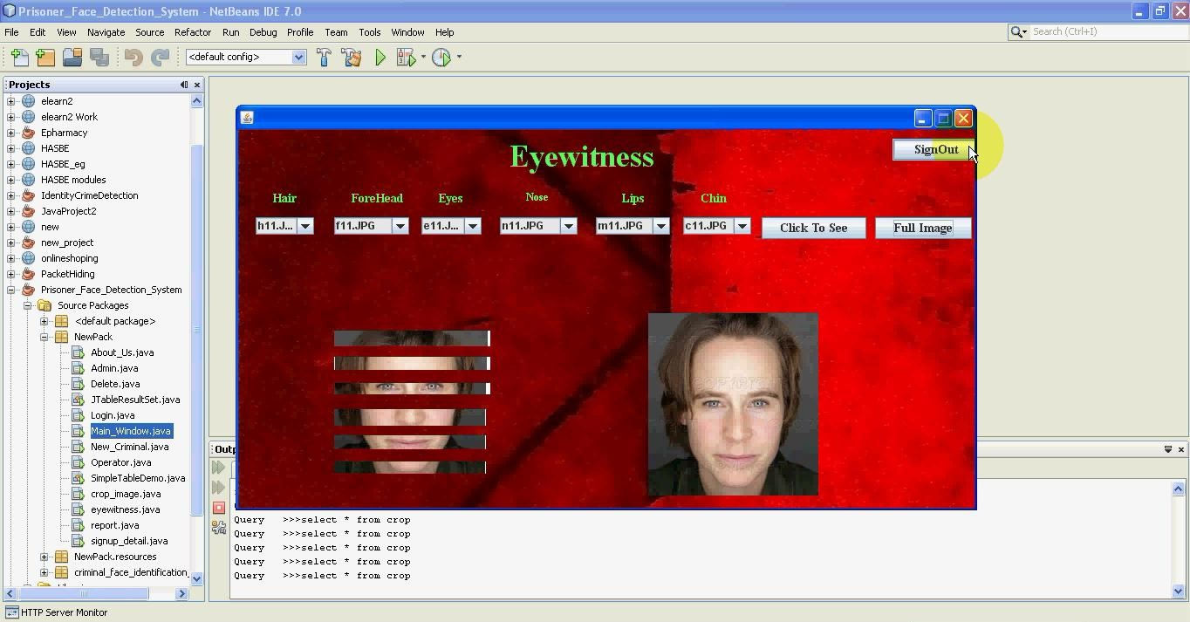**Fig 9.8 Image Found Page**

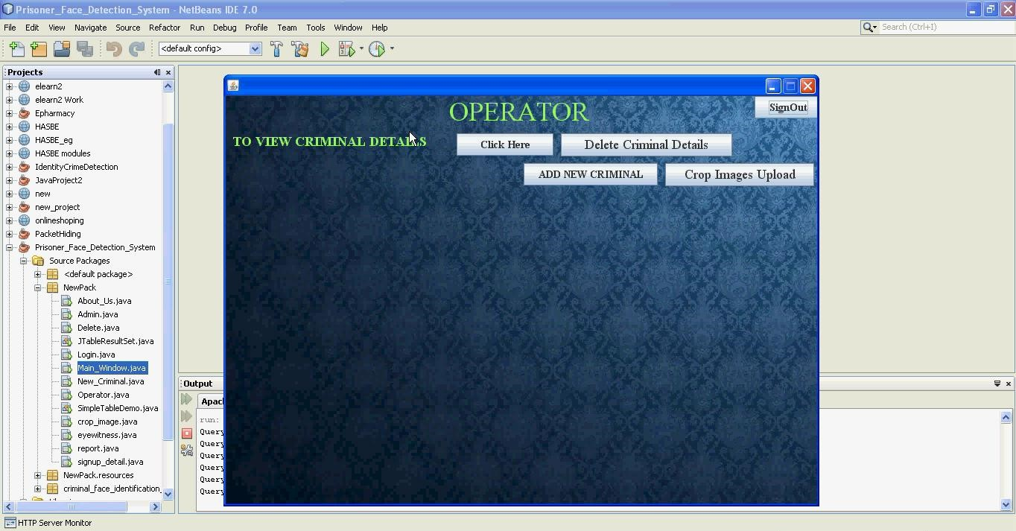

**Fig 9.9 Operator Page**

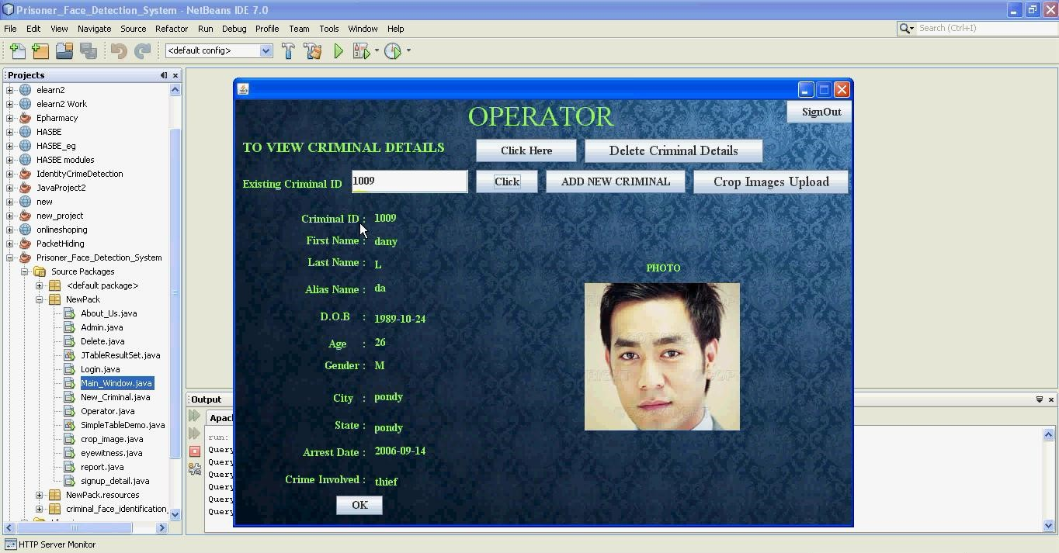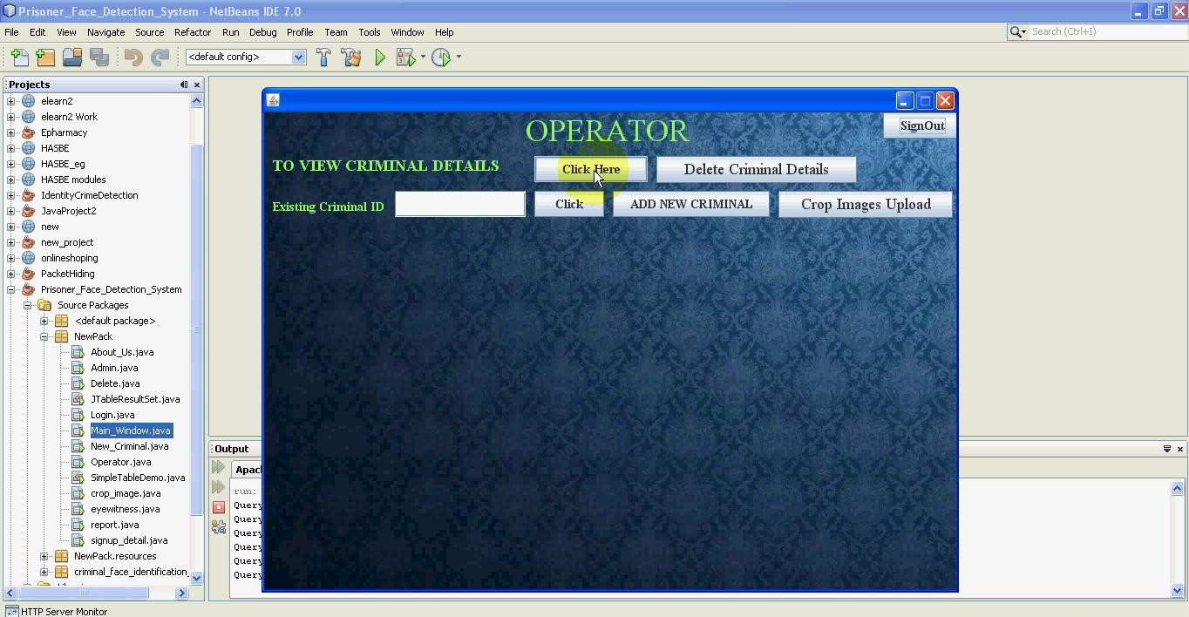**Fig 9.10 To View Criminal Details Page**

**Fig 9.11 Criminal Details Page**

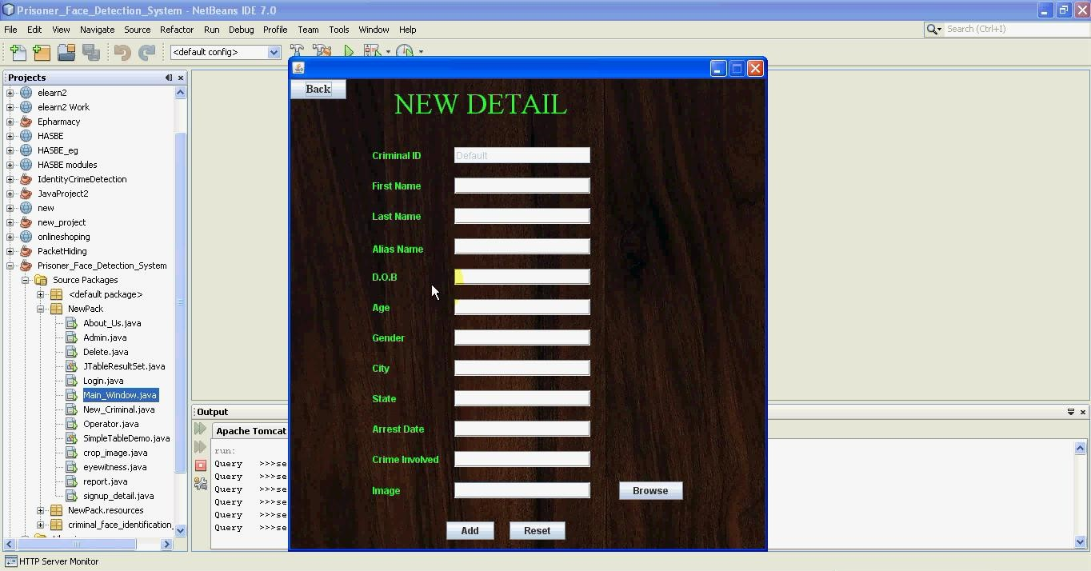 **Fig 9.12 New Detail Page**

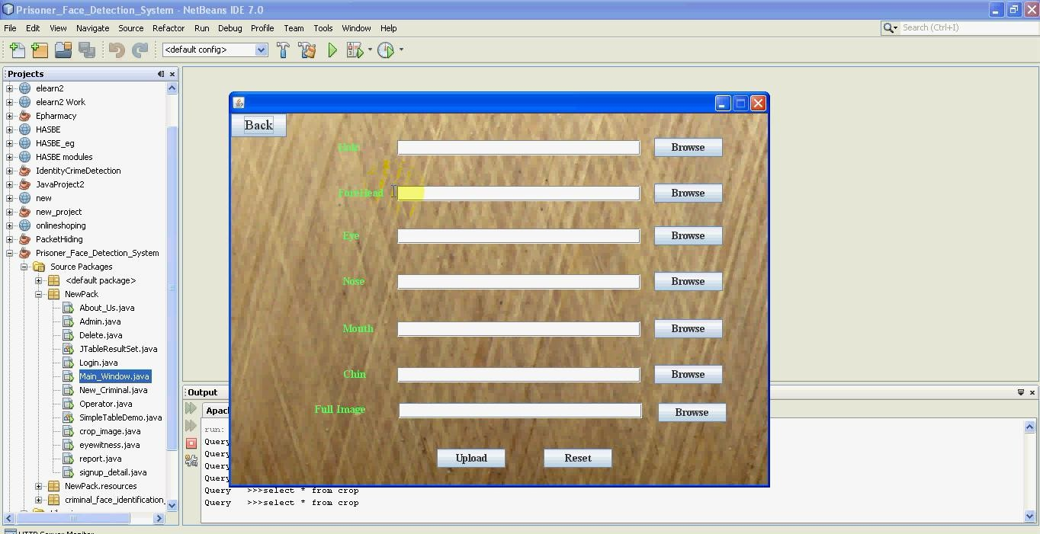

**Fig 9.13 New Image Upload Page**

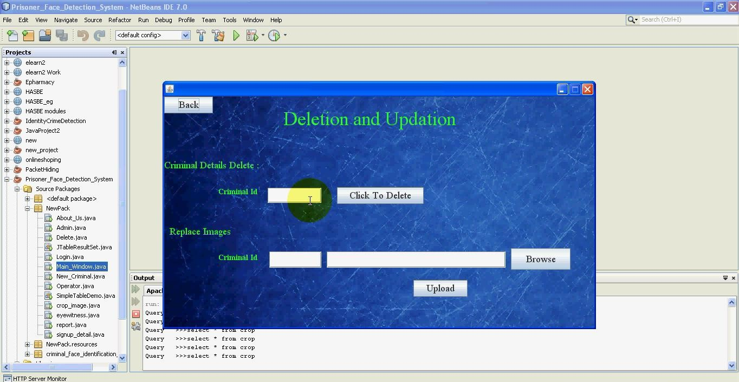**Fig 9.14 Deletion and Updation Page**

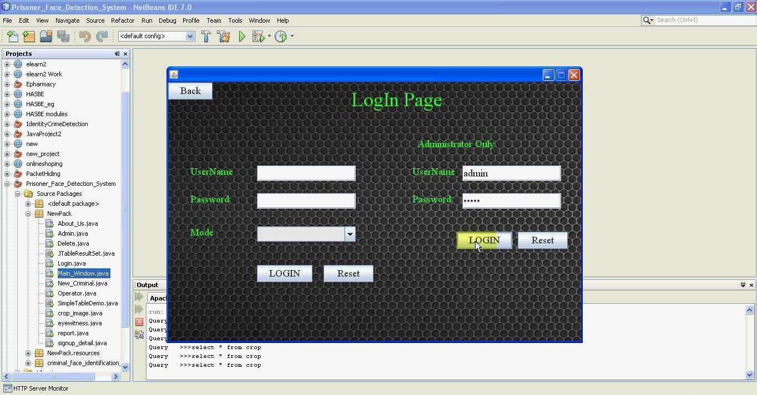

**Fig 9.15 Admin Login Page**

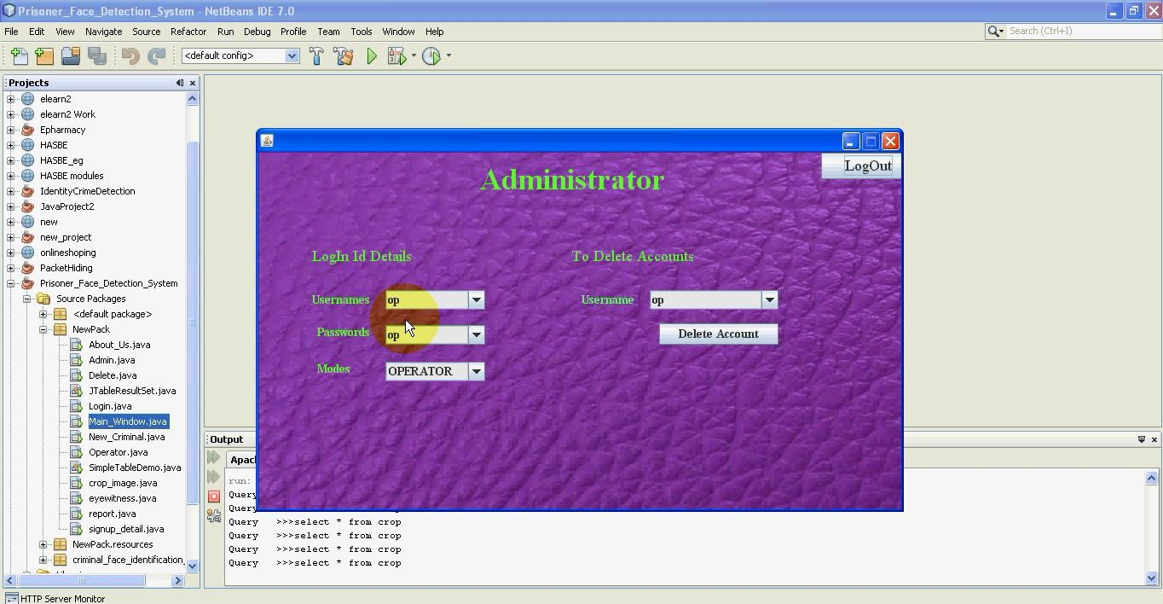

**Fig 9.16 Administrator Page**

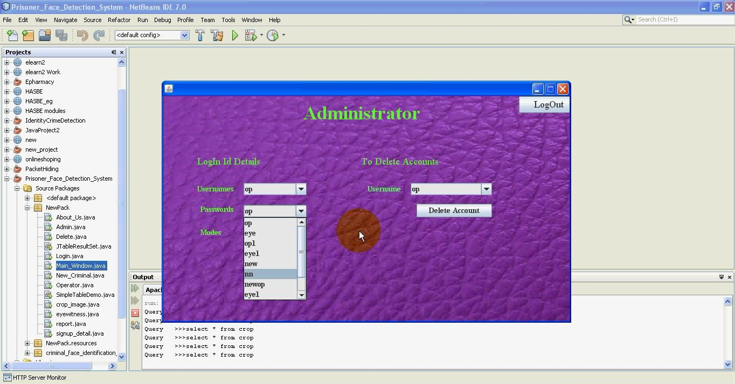

**Fig 9.17 Login Id Details Page**

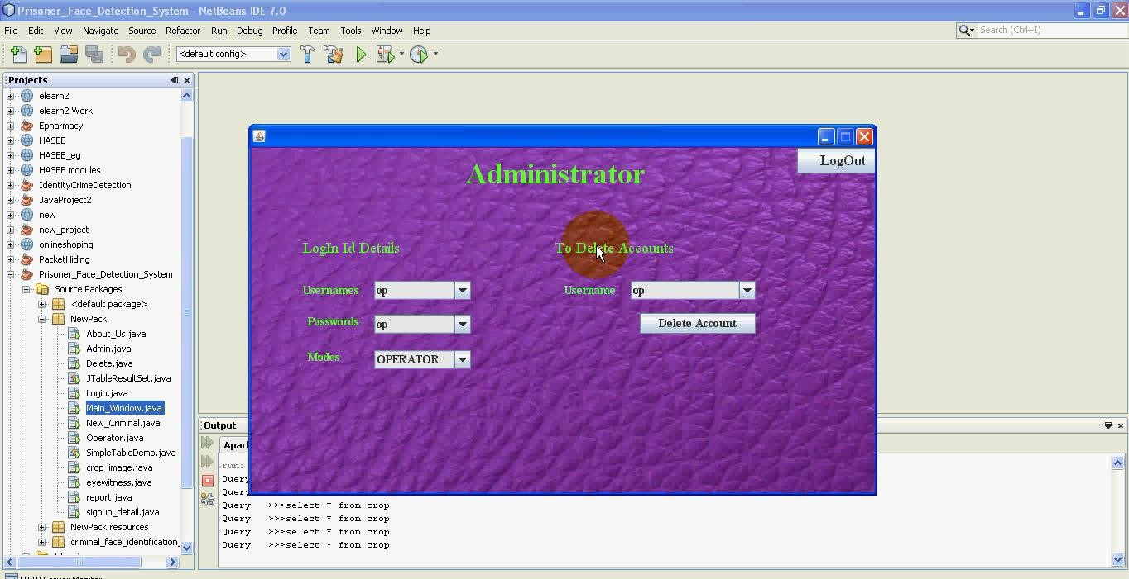**Fig 9.18 To Delete Accounts Page**

**CHAPTER 10**

**Conclusion and Future Scope**

**10.1 Conclusion:**

Traditionally, identifying criminals relied heavily on manual effort, which, while accurate, was often time-consuming and resource intensive. Our project endeavours to revolutionize this process by leveraging machine-based face identification techniques. At the core of our approach is the organization of criminal information, including images, into a structured database.

In our system, images of criminals are meticulously analyzed and broken down into separate facial features such as hair, eyes, nose, and lips. This segmentation allows for a more detailed examination and comparison during investigations. When eyewitness descriptions are provided, our system compares these descriptions to the stored images, searching for potential matches.

To enhance the accuracy of identification, our system employs advanced image processing techniques. These techniques enable us to merge the segmented facial features, reconstructing a clearer and more comprehensive picture of the suspect. By synthesizing these features, our system facilitates a more accurate matching process, aiding law enforcement agencies in their investigations.

The implementation of machine-based face identification significantly streamlines the process of criminal identification. By automating the comparison and matching of facial features, our system reduces reliance on manual labor, thereby improving overall efficiency. Additionally, the use of technology enhances the accuracy and reliability of the identification process, leading to more effective law enforcement outcomes.

Overall, our project represents a significant advancement in the field of criminal identification. By harnessing the power of machine-based techniques and advanced image processing, we aim to revolutionize the way criminal investigations are conducted, ultimately contributing to safer communities and more efficient law enforcement practices.

**10.2 Future Scope:**

As we move forward with the development of the Facial Recognition and Criminal Identification (FRCI) system, rigorous testing and debugging procedures will be essential to refine and optimize its performance. Given the constraints of time and resources, it is crucial to ensure that the system operates flawlessly and reliably in real-world scenarios.

One of the significant advantages of our system being open source is the flexibility it offers to developers. This flexibility allows for the incorporation of new functionalities and the enhancement of existing ones based on evolving needs and technological advancements. An area ripe for enhancement is the integration of advanced image processing capabilities to improve the clarity of input images. By implementing sophisticated algorithms, the system can effectively detect and analyse faces even in lower quality images, thereby enhancing its overall accuracy and reliability.

Additionally, integrating access to a comprehensive database containing personal information can greatly enrich the system's functionality. By leveraging a vast repository of data, the FRCI system can provide valuable insights and context about individuals identified through facial recognition. This integration would enable seamless access to relevant personal details associated with each individual, such as criminal records, identification documents, or demographic information.

Furthermore, ongoing research and development efforts can focus on refining the system's algorithms and optimizing its performance across diverse environments and conditions. Continuous improvement initiatives will ensure that the FRCI system remains at the forefront of facial recognition technology, capable of delivering accurate and actionable insights to law enforcement agencies and security professionals.

In summary, through rigorous testing, debugging, and ongoing enhancements, the FRCI system holds the potential to revolutionize the field of criminal identification and public safety. By leveraging open-source principles and embracing advancements in image processing and data integration, we can create a powerful and effective tool for combating crime and enhancing security in our communities.

**Bibliography**

**Java (Swing & XML):**Java in a NutShell O’RiellyUsing Java2 Platform Joseph WeberThe Complete Reference Java 1.2 Herbert SchildtCore Java Kenneth Paul

**System Development:**Fundamentals Of System Concepts Jerry Fitz GeraldSystem Analysis and Design Elias M. AwadObject Oriented Modeling and Design James Rumabah

**Paper publications**

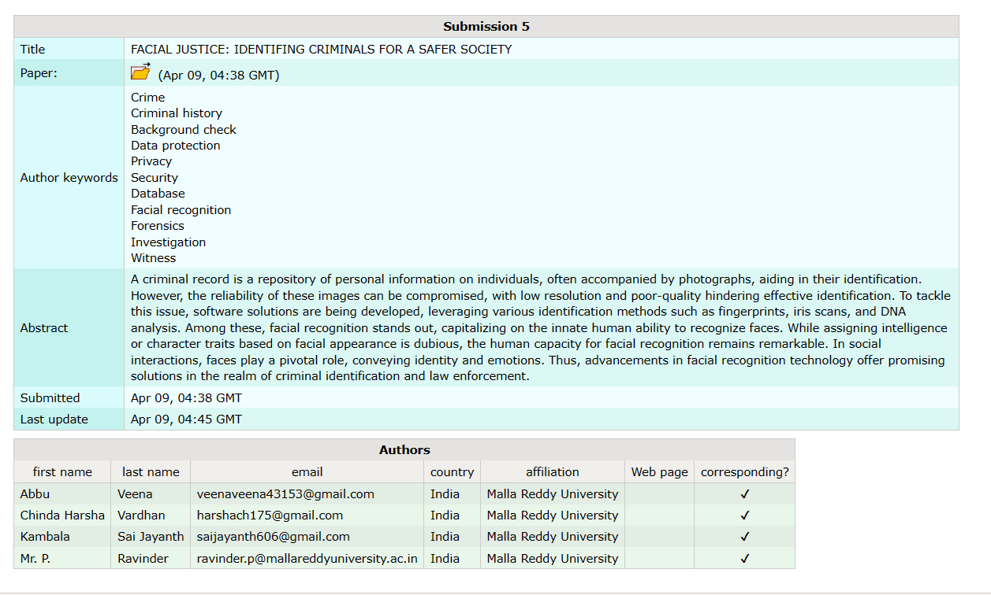

**REFERENCES**

[1]. Application of face recognition method under deep learning algorithm in embedded systems.

[2]. Face Recognition- NSTC Committee on Technology Committee on Homeland and National Security Subcommittee on Biometrics.

[3]. Fu Jie Huang Zhihua Zhou "Pose Invariant Face Recognition”. International Journal of Engineering Research & Technology (IJERT).

[4]. M. A. Turk & A. P. Pentland. “Face Recognition Using Eigenfaces.” MIT Vision and Modeling Lab

[5]. M. F. Smith, Software Prototyping: Adoption, Practise and Management (McGraw-Hill, London, 1991)

[6]. Adriana Kovashka Margaret Martonosi- Feature-Based Face Recognition for Identification of Criminals vs. Identification for Cashless Purchase.

[7].Ole Helvig Jensen "Implementing the ViolaJones Face Detection Algorithm".

[8]. Rabia Jafri* and Hamid R. Arabnia* A Survey of Face Recognition Techniques.

[9]. Belhumeur, P. N., Hespanha, J.P., Kriegman, D. J. (1997). Eigenfaces vs. Fisher faces: Recognition Using Class Speciﬁc Linear Projection.IEEE Transactions on Pattern Analysis and Machine Intelligence. 19, pp. 711-720. IEEE Computer Society.

[10]. Bornet, O. (2005, May 19). Learning-Based Computer Vision with Intel’s Open-Source Computer Vision Library. Retrieved April 2007, 2007.

[11]. Brunelli, R., Poggio, T. (1993). Face Recognition: Features versus templates. IEEE Transaction on Pattern Analysis and Machine Intelligence,15 (10), 1042-1052.

[12]. Viola, P. and Jones, M. Rapid object detection using a boosted cascade of simple features. IEEE Conference on Computer Vision and Pattern Recognition, 2001.

[13]. P. Viola and M. Jones. Robust Real-time Object Detection. International Journal of Computer Vision, 57(2):137–154,2002.

[14]. Lorencik, D., Ondo, J., Sincak, P., Wagatsuma, H. (2015). Cloud-Based Image Recognition for Robots. In Robot Intelligence Technology and Applications 3 (pp. 785-796). Springer, Cham.

[15]. https://en.wikipedia.org/wiki/Cascadingclassiﬁers